**Student reports Mobility Turkey**

**Karaman, Turkey**

*October 9th - 13th*

Monday : Every land gave an presentation about there product and the benefits of it, that day we went to a market and we bought apples. we were separated in seven groups and the group which bought the cheapest but also most beautiful apples won. We went down the market and asked some prices but they were to expensive but the third man would give his apples much cheaper and we were able to bargain the price so we got them even cheaper. our group didn't win although we had one of the cheapest apples but we didn't win because the outside of the apples were really bad. so that day we learnt how to bargain a price and we learnt that the outside of the apples is important to.

Tuesday : we went to visit a factory in the morning a helva factory it was really delicious and it is made by machines. it was a tiny factory and next to the factory the shop of the factory was and it was also really tiny. they gave us to taste two boxes of helva which is kind of compared to a box of hay but only is helva delicious and edible, but that was a smart move because everybody tasted it and they found it so delicious that they bought a lot.

Wednesday : In the morning we went to a bagel shop and again we bargained the price and we got fifteen bagels for really cheap. Then we went to a private school and we tried to sell the bagels, our group tried really hard by screaming about our bagels and give our bagels for a lower price than the other group next to us still the other group was earlier sold out and made more money. because they didn't use the screaming but they gave by every bagel one hand of candy's and a plate for the bagels. so we learnt that if you want to sell a product it is smart to give something for free within. In the afternoon we went to visit a university where we learnt a lot about selling a product and presentate a product cause people don't care about of what the product is made or the history of the product no you have to tell the people how they become if they use your product. like the game mario where mario eats a flower and than become super mario that is what the people want to hear. The last thing we did that day before the big party was going to a cookie factory, the man gave us a tour around it and told us that we were allowed to eat everything and as much as we wanted to ofcourse nobody ate like 100 cookies because after ten cookies you feel like you had enough. we also were not allowed to make pictures because the competitor could see those pictures and could see how they make there cookies and copy it. it is good for the consumer if they copy it because that would mean cheaper cookies because this 'new' way could be better and maybe cheaper for the company so they can sell there product for less and when that happens the competitor maybe also lowers there price.

Thursday : we went on a really big ship in the morning and we had a lot of fun by the end of the day we went to a restaurant and had a delicious meal, for me this day was the best day because the ship tour around the beautiful sea was really nice.

Friday : on Friday which was our last day because our plane left that night we had to give a presentation about selling a product and buying a product, in the presentation we put from everyday the point of what we learnt. out of the other presentation I learnt that not only telling of how you become whit the product is important but also decoration is important and to put on your biggest smile and be really confident about your product and just sell it.

Eline van de Voort

**Erasmus exchange**

**Karaman, Turkey**

**09-10-2017 ~ 13-10-2017**

***Monday 09-10-2017***

We started the week with an opening ritual in front of the school. Everybody stood in line and sang the national anthem. After which the program for the week started. There was an opening ceremony and a tour through the school. In the afternoon there was a challenge to buy apples. On the local market we were given the assignment to buy two kilos of apples for the lowest price. The normal price of one kilo of apples was two liras so, we did well when we got our two kilos of apples for two liras. Later that afternoon we visited a typical Turkish house.

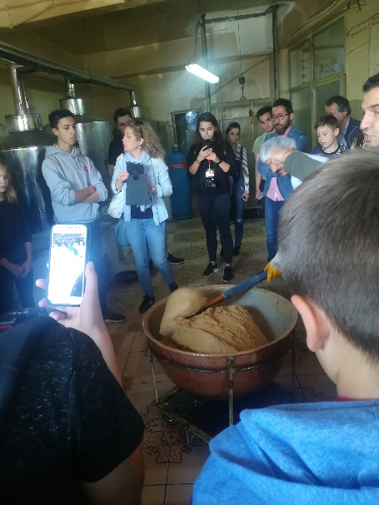

***Tuesday 10-10-2017***

Today we went to Ermenek, a five hours drive by bus from Karaman. In Ermenek we visited a factory where they make helva. Helva is a typical Turkish sweet a bit like nougat. During a tour through the factory they showed us how they produce helva and we got to taste some of it. Ermenek is positioned at a lake where we did a boat tour in the afternoon.

***Wednesday 11-10-2017***

Today we were given the assignment to buy bagels for the lowest price and after that sell them for the most so we have the highest margin. We had to perform this task with mixed groups having people from all participating countries in the group. First of all, at the bakery we had to negotiate the price of the bagels. The normal price was fifteen bagels for fifteen liras. After negotiating we got fifteen bagels for 9,70 liras. The next thing we had to do was to sell the bagels at a designated school. In our case this was the Karaman Lisesi, the school where we were the hole time. We sold the bagels in front of the school at breakfast time during the break. We sold all the bagels for forty-four liras. The margin was 34,30 liras. After we sold the bagels we went to the university for a presentation about how to sell your product. I personally learnt that it is important to prepare how to sell your product and also understood the importance of a good presentation of the product. In the afternoon we went to the Şimşek factory where they make pastries and chocolate. At first we got a presentation about the factory after which we got a tour through the factory. At the end we got the opportunity to taste all the chocolate and cake.

***Thursday 12-10-2017***

Today we had the hole day a yacht tour at the sea. It was a very nice tour and we saw a lot of the beautiful nature and blue sea of Turkey. The boat tour itself had nothing to do with the subject of the week: buying and selling but was a very nice event to get to know each other better.

***Friday 13-10-2017***

Today we had to do our presentation of the Cycle Basics app. Most of the groups did this already on Monday but because we were not prepared we did the presentation on Friday. 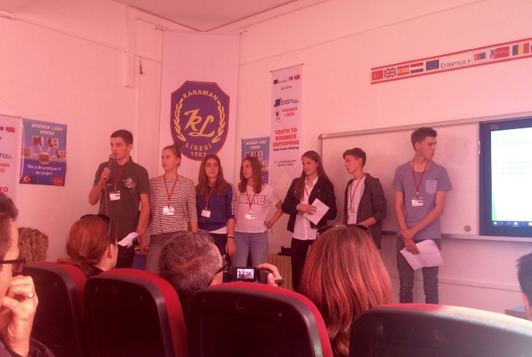Besides the presentation about our Cycle Basics app we also had to present what we learnt during the week. The presentations about our learnings of the week were done with the groups as organized when buying and selling the bagels earlier in the week. In the afternoon we had free time and we went shopping with the Dutch girls and their hosts. Later in the afternoon we went to Go Kart with all the Dutch people, their hosts and some other Turkish people. In the evening we had to go back to The Netherlands. After an emotional goodbye we left by bus for the five-hour trip to the airport.

It was a very nice week and I enjoyed it very much!

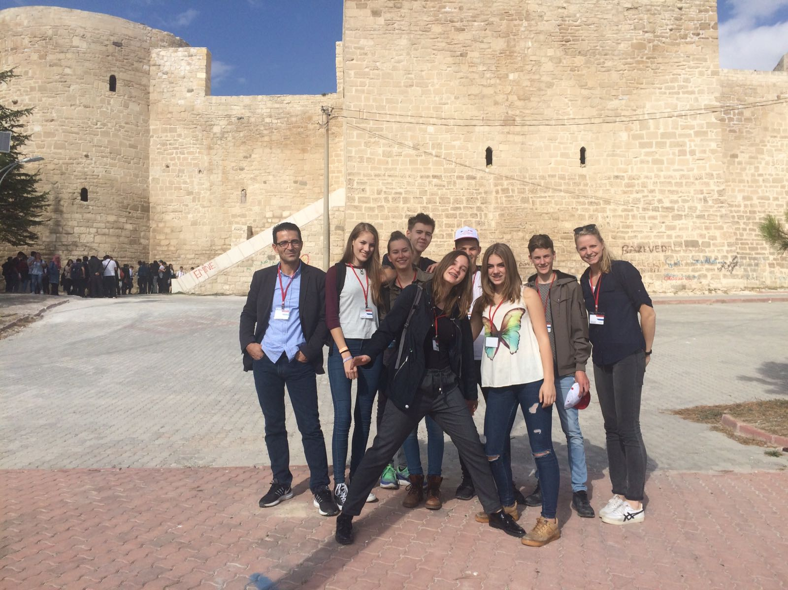

Annick van Tilburg

The Netherlands

Pallas Athene College

Monday 9-10-2017

At 9am in the morning a welcome ceremony was held. The head of the school and the English teacher talked about how happy they were that we were joining them for this week. They continued with explaining about how the week would look like.

After the ceremony was done we and the other countries went to see the whole school. Our tour guide was called Sertac and he was almost fluent in English so we could understand it well. The classrooms and school looked a bit different than here in the Netherlands. After the school tour every country was going to present her project. This project was developed since the beginning of Erasmus.

After all of this was done we went to see the beautiful city a Karaman and a museum. Before we went to see the city we were divided into mixed groups with people from different countries. This was needed for the ‘’sale workshop’’. We were sent to a bazaar where we had to buy the cheapest, sweetest and shiniest apple. Our group did not win.

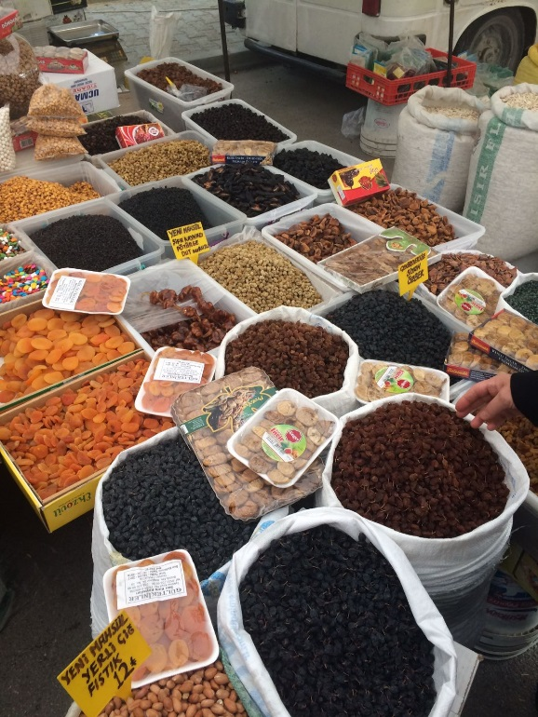

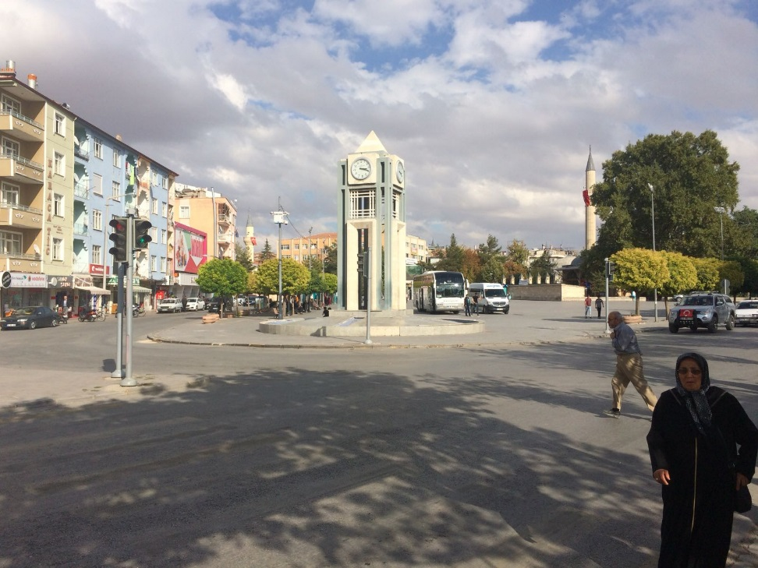

Tuesday 10-10-2017

We left early with the bus to go to a city called Ermenek. We had to travel for a really long time because the bus had problems with the engine. We went to see how Helva is made, we also got to try how it tasted this was smilliar to peanut butter. Helva is traditional food in Turkey.

In the afternoon we went to a lake. We had lunch and were visited by political people from Ermenek. The original plan was that the mayor would visit us but he was sick. We had a boat trip from 30 minutes on the lake it was very beautiful and I enjoyed it a lot. At the end of this amazing day we went to a Turkish restaurant with really good food.

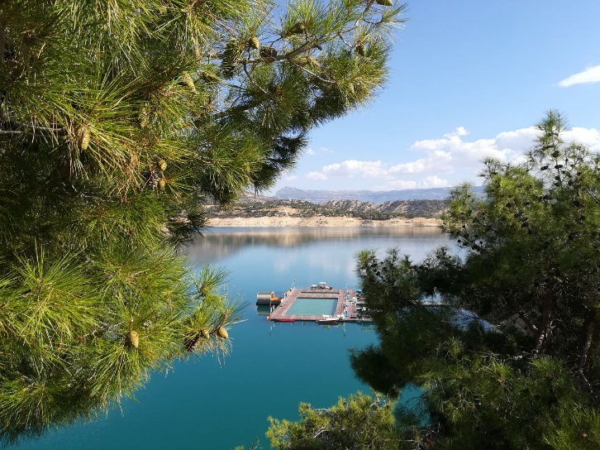

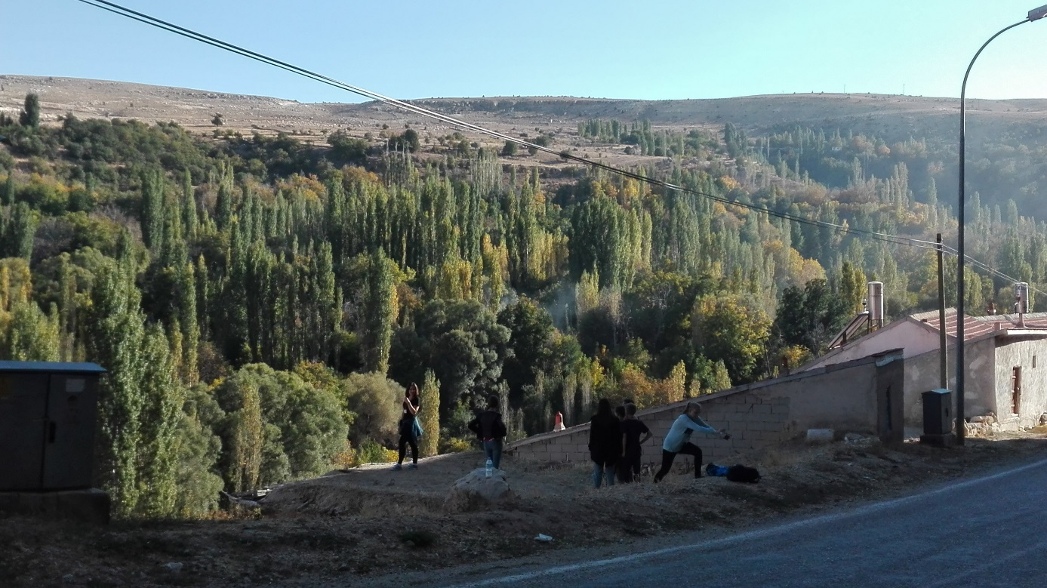

Wednesday 11-10-2017

In the morning we had another sales assignment with our group. We went to a bagel store and tried to get 15 bagels for a cheaper price. After all the groups bought bagels we were send to different schools to actually sell them. My group was send to a private school. It was really fun because my group screamed a lot of things in Turkish. We also earned a lot of money and actually won the competition.

Around 11am we took the bus to the university because one of the teachers was going to give a college about sales. It was very interesting and I actually learned something more about sales. We had lunch at the school and then left for a visit to the cookie factory. The man who was giving us a introduction was really funny and kind, he also told us to eat as much as we wanted. A lot of people actually had pain in their belly from eating so much cookies and sweets……

At night we had a huge party in a hotel. We could dance and sing a lot and it was so much fun, so it was really sad that it ended early because we needed to leave at 6am in the morning the next day.

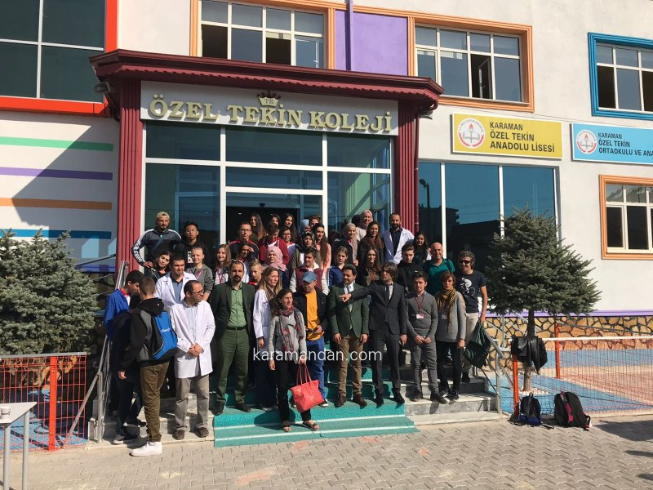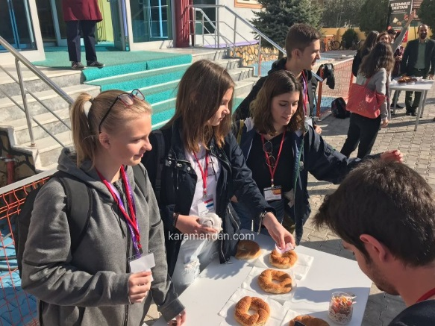

Tuesday 12-10-2017

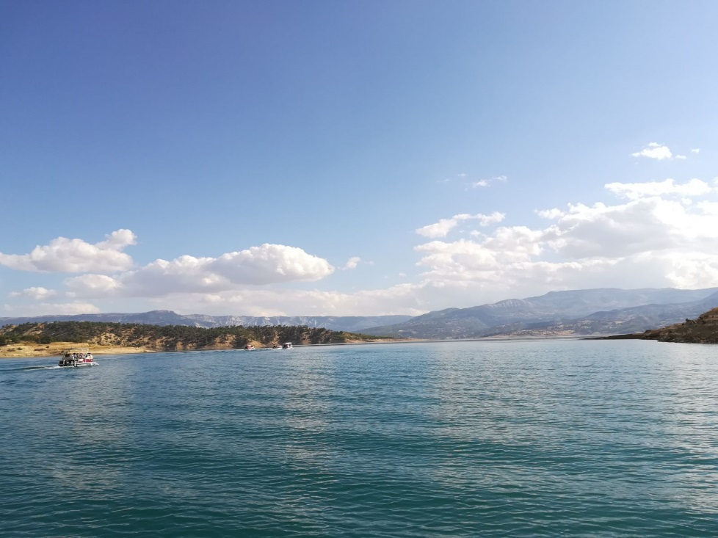We left early so we could have breakfast on our trip to the boat. We stopped like 15 minutes away from the restaurant so we had to walk. The view was really beautiful and we had a nice breakfast. We arrived at the port and got inside the boat. We stayed on the boat for a really long time. We had 4 stops on the sea so we could swim. We also played some mini games on the boat and had a soap party. After our boat trip we went to a restaurant and ate Turkish pizzas.

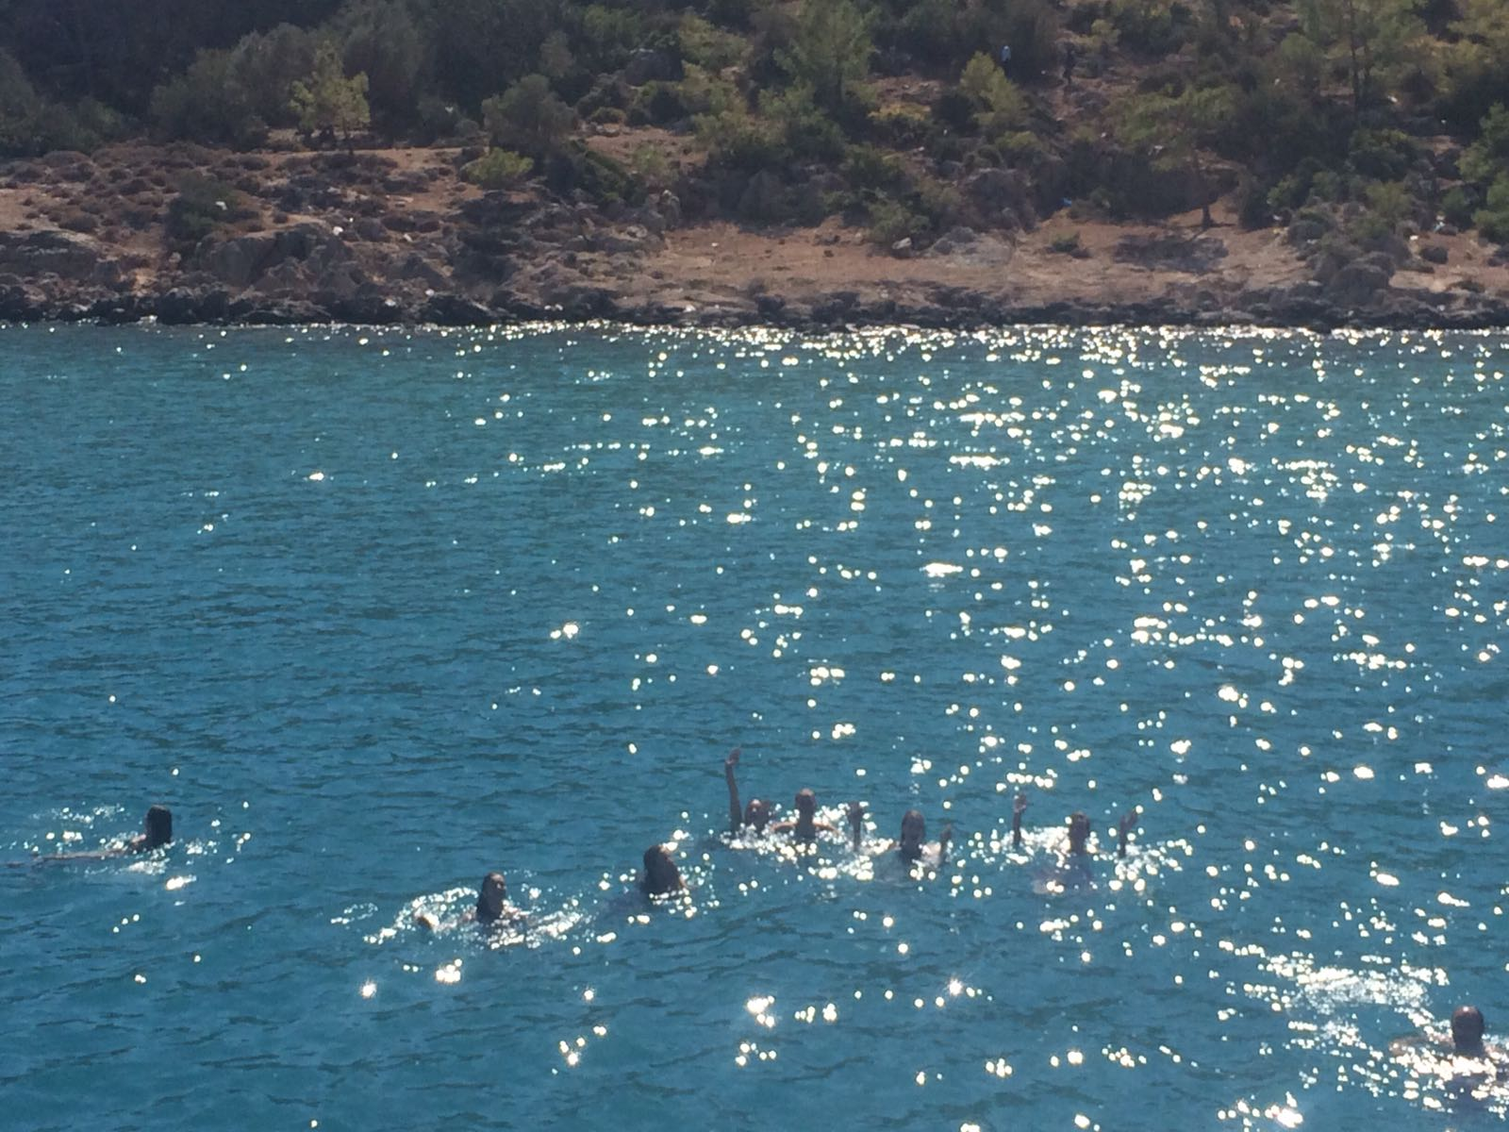

Friday 13-10-2017

It was the last day so we made a presentation about what we did this week. We got together with our groups and had about 1 hour to make the presentation. All the groups told about their experiences and after every group was done we got closing ceremony. Everybody got a certificate and a little present. The two groups that had won the sales competitions got an extra present ☺. We said goodbye to all the friends we made and left to have fun in our free time.

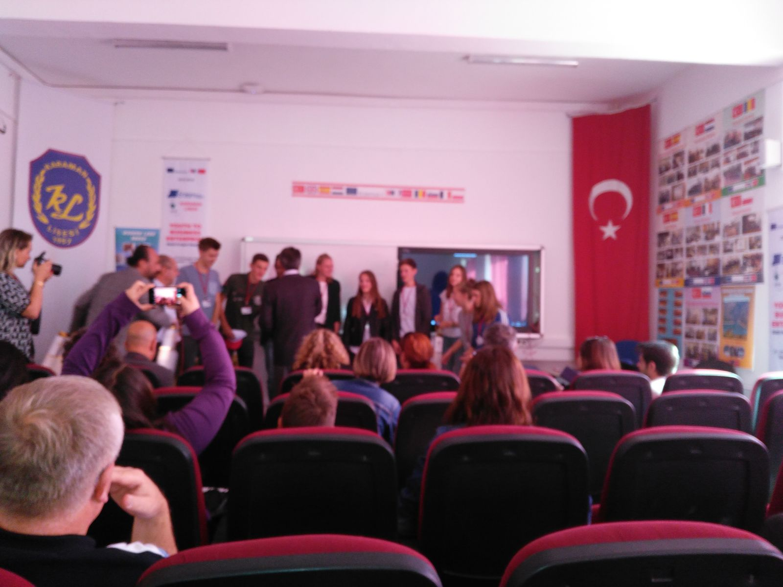

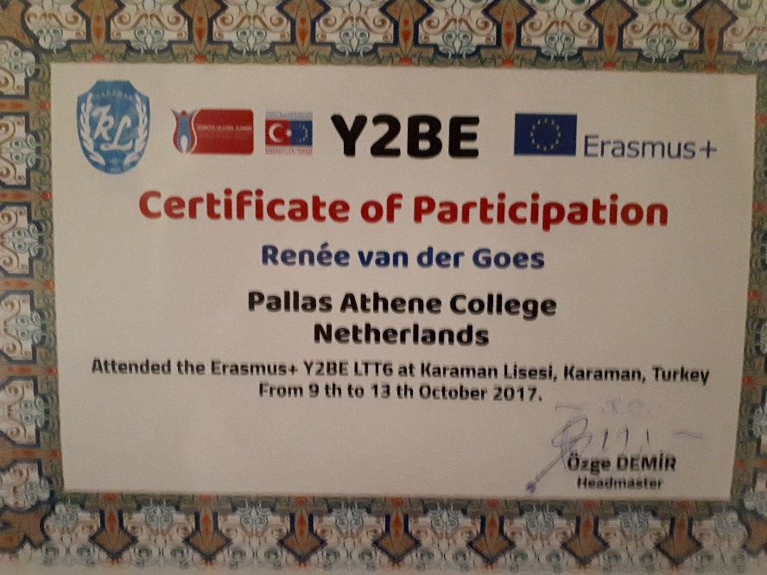

End

It was a really amazing and good experience I made a lot of friends and had a lot of fun. Even though it was really scary in the beginning you get comfortable so easy. Thank you all for this great week.

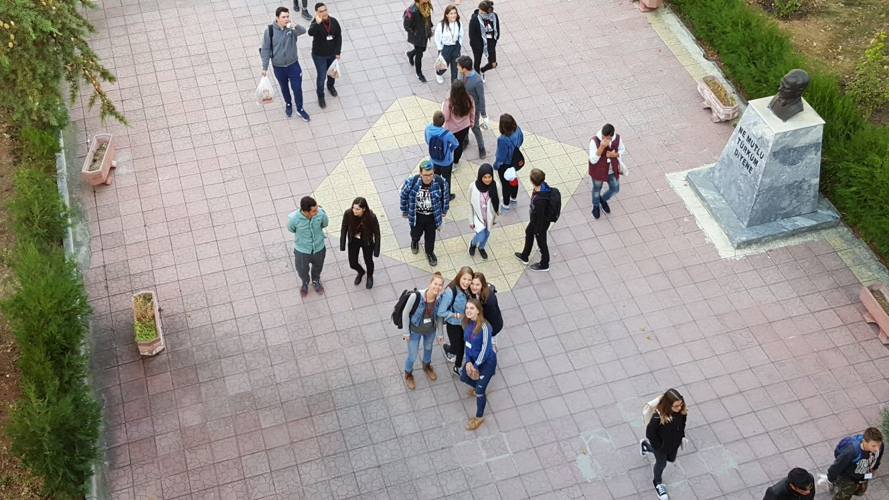

Reneé van der Goes

Karaman, Turkey

October 9th - 13th

Esmee Lam

# Monday, October 9th

On Monday we were welcomed by Karaman Lisesi. We opened the week with presenting the business plans. The ideas of the other countries were very interesting.

Then we were divided into groups with people from different countries.

In the afternoon we did a beautiful tour through Karaman.

Then we got the assignment to buy the most beautiful and cheapest apples on the market with the groups made earlier today. According to the jury, our group had the most beautiful and cheapest apples. So we had won the game!

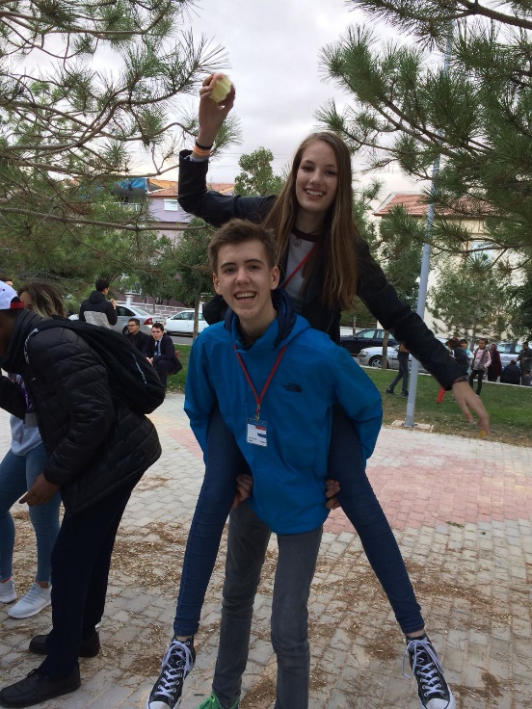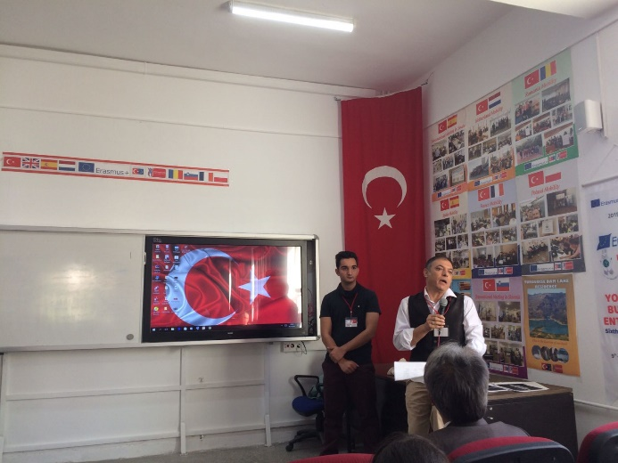

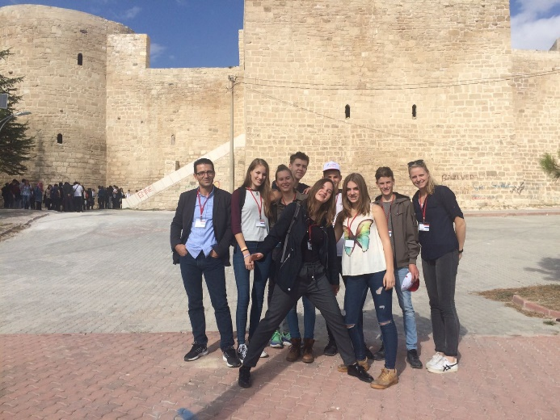

# Tuesday, October 10th

On Tuesday we went to the Helva factory. Helva, is one of the most unique Turkish products that reflects the Turkish taste that is known around the world. Helva is made from two main ingredients; tahini and sugar.

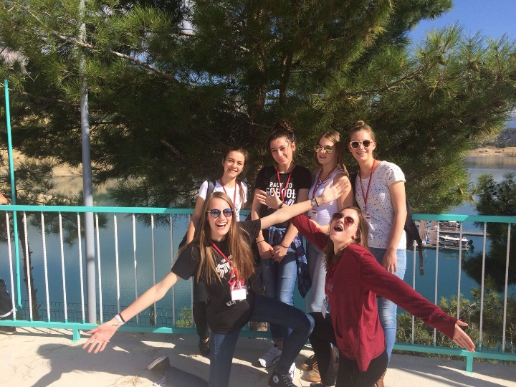Then we went to Ermenek. There we got a boat tour over the lake.

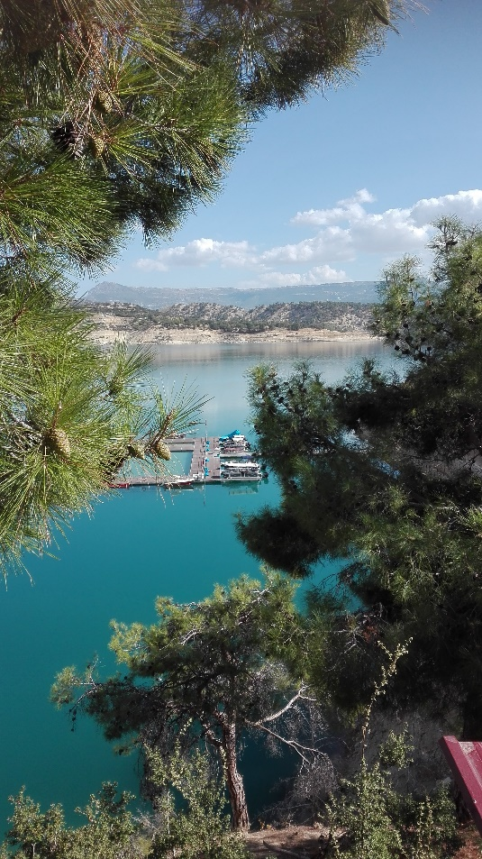

# IMG_20171010_152039[417]Wednesday, October 11th

Wednesday morning we went to the bakery to buy ‘sikit’ (Turkish Bagel). We had to sell those bagels at a primary school. We wanted to sell the bagels for two Turkish lira. The little boys at the primary school were very active and didn’t have a lot of money. It was hard to sell the bagels. But with a lot of patience we succeed selling the bagels. And I think patience is the most important thing when you want to sell something, especially with kids.

After selling the bagels we went to Karamanoğlu Mehmetbey University. There we got a presentation about sales. I have learned that it is very important to create value for your product.

At 14 PM we went to the Şimşek factory. Şimşek produces biscuits and other food.

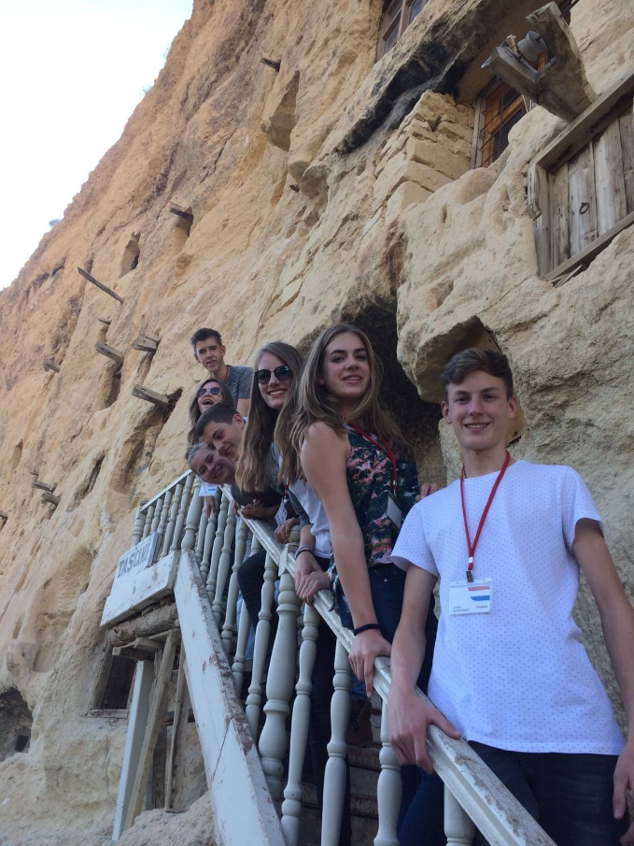After the factory visit we went to Taşkale. Taşkale is a small village in Karaman.  
In a huge rock wall at the beginning of the place were small openings. There openings were used as homes or storage. There was also a mosque in the wall.

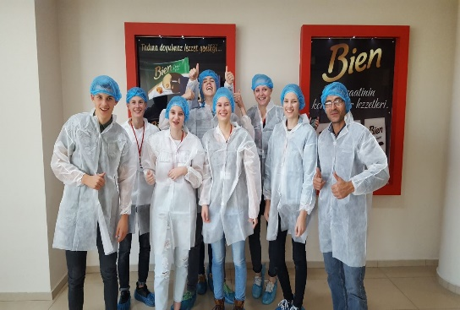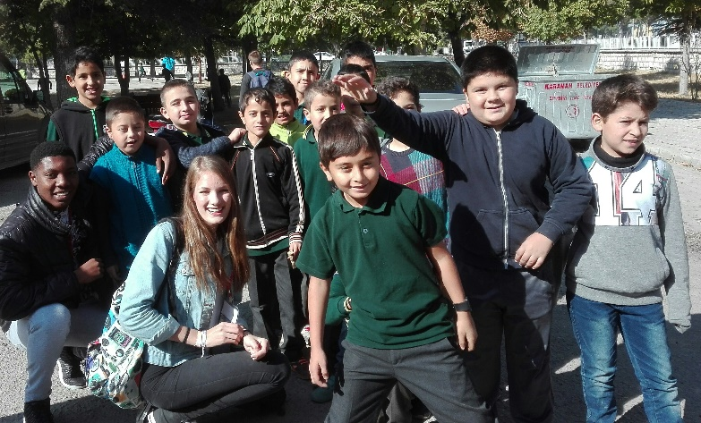

# Thursday, October 12th

Thursday we started very early. First of all we had breakfasts with the whole group and then we all went to the sea at Taşucu for a boat trip. We had a very nice day.

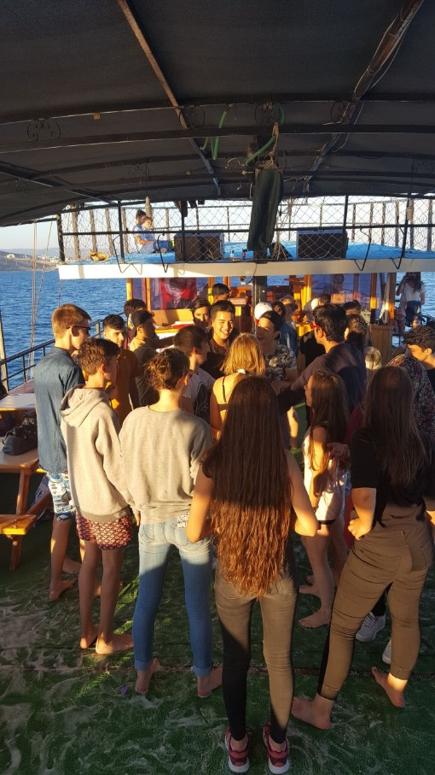

# IMG-20171013-WA0026[458]IMG-20171012-WA0002[456]

# Friday, October 13th

Today was our last day at Karaman Lisesi. With the groups we had made earlier this week, we had to give a presentation about our experiences this week. Because we all spoke a different language and not everyone could speak English, it was very difficult to communicate. But we succeed and we did a really nice presentation.

After that, we all got our certifications.

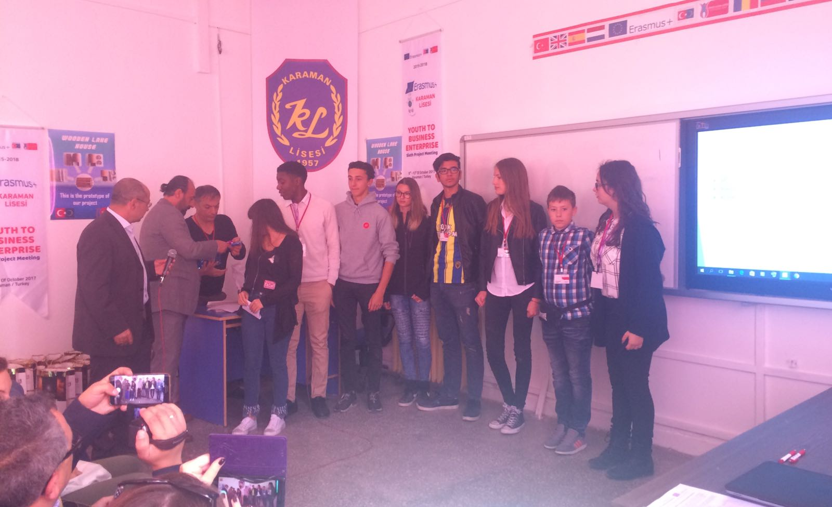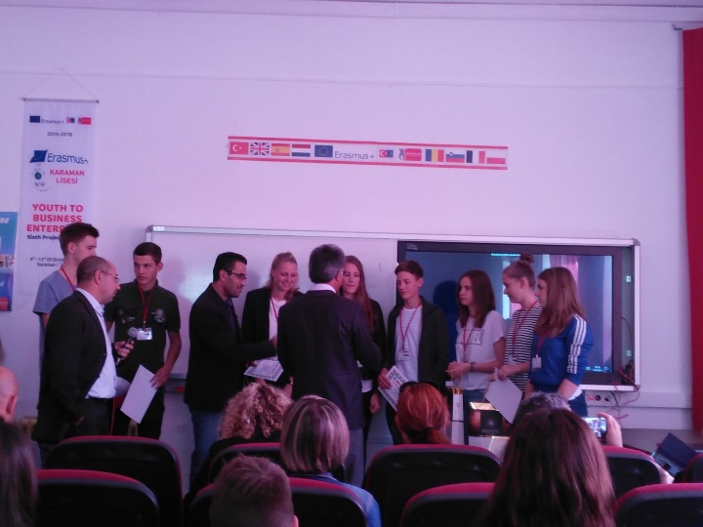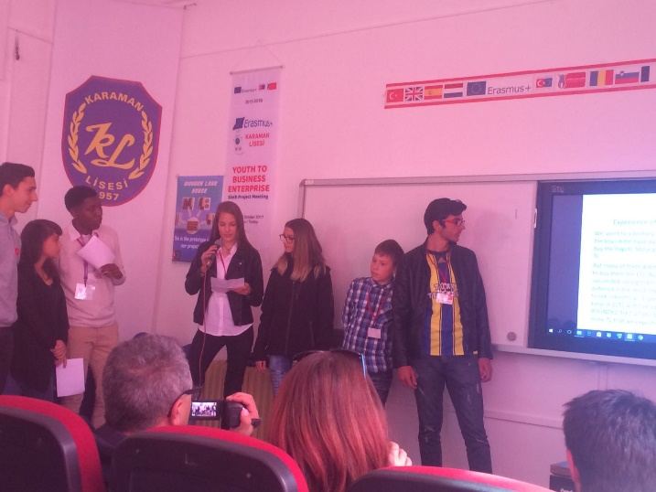I had a very interesting and fun week. I learned a lot about sales and communication, but especially about the Turkish culture.

**Lucas Vandersteen**

**Monday 9-10**

At 9am we had to be at school for the opening ceremony. The headmaster welcomed us at the school and that he hoped the students would a have good time in Karaman. The headmaster spoke Turkish, but a teacher translated everything into English.

After that a boy guided us and showed us the entire school. The school looked very different from the schools in the Netherlands. After we saw the school, we had to present our projects. The project we’re working on is about making a company. The Dutch company is an app, which helps people to learn cycling.

We thought we had our presentation on Friday. That’s why we didn’t do it on Monday, like the other groups.

Everyone was divided into one of the seven groups. In every group there was someone from every country. In this group we did the two ‘Sales workshops’. After the groups were made, we had a city tour. We went to the Karaman Castle, a mosque, a traditional house and a museum.

Then we went to the market for the first workshop. We had to buy 2 kilos of apples for the lowest price.

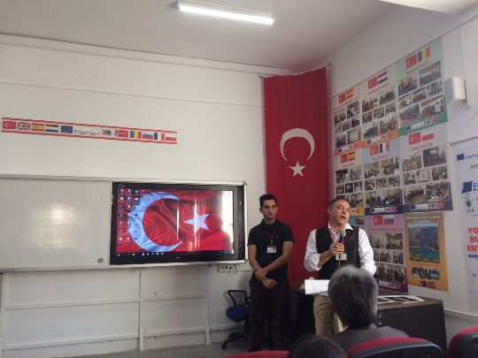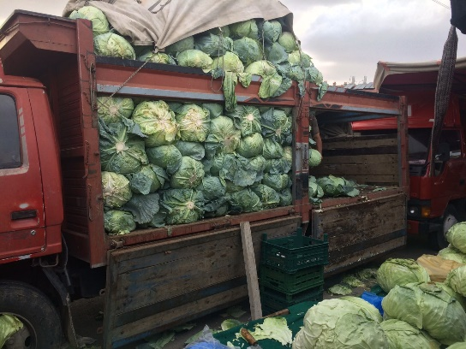

**Tuesday 10-10**

By bus we went to a place called Ermenek. One bus had some technical problems, that’s why we travelled for a few hours before reaching Ermenek. First we went a small company where they made Helva. We saw how it was made and we tasted it.

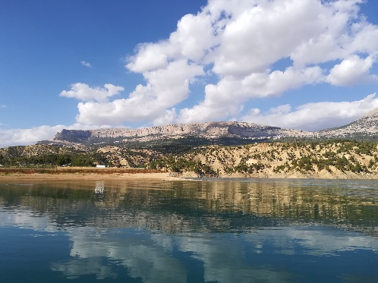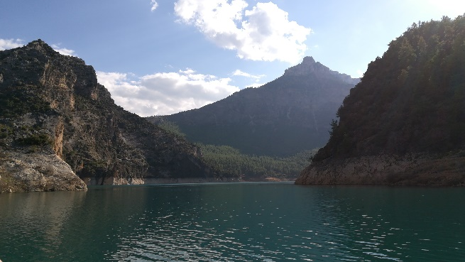After the lunch, the mayor of Ermenek would come to visit us, be he was ill. Then we had a boat tour on the lake. The view was absolutely stunning. Then we had diner at a Turkish restaurant.

**Wednesday 11-10**

In the morning we had workshop 2. First we went to the bakery to buy bagels. We had to negotiate about the price, to get the cheapest bagels. After we bought 15 bagels, we went to another school to sell them. Our group tried to sell the bagels to the teachers first, because they had more money than the students. We bought the bagels for 0,65TL and sold them for over 2TL. We made a lot of profit, but didn’t won.

We went to the university for a college about sales. It was about the best way to sell your product, I learned a lot from it and it was very interesting.

After lunch we visited a cookie factory. Someone told us about their company and they showed us the production lines. We could taste as much as we wanted. We also went to a place with a lot of caves where they used to store products because it’s cold inside.

In the evening there was a party at the hotel. It was really fun. Everybody was dancing and singing but it was over too early, because we had to sleep.

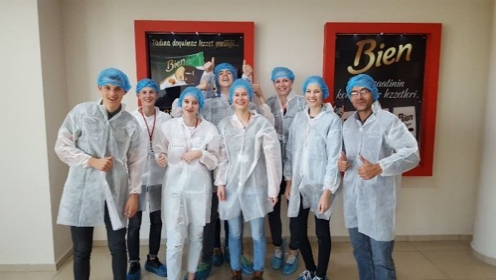

**Thursday 12-10**

We left at 6am and we had breakfast on the go. The plan was to go to an oil factory, but we went straight went to the port to get on the boat. We stayed on the boat the entire day. We could swim, play games and dance. It was really nice. We ate Turkishpizza for diner before going back to Karaman.

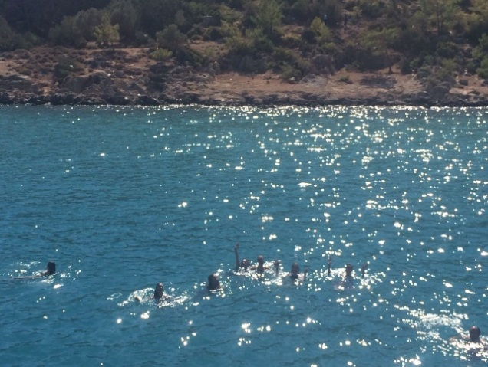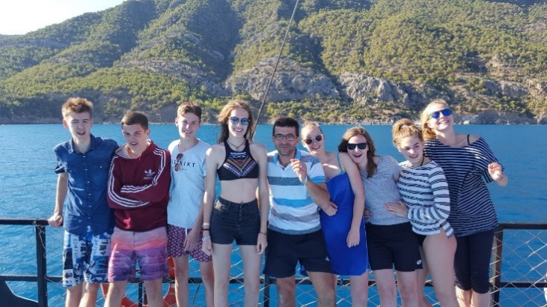

**Friday 13-10**

We made presentations about the workshops and what we learned that week, we did this in the groups we were in the entire week. Every group presented their experiences. Then we, as the Dutch group had the presentation the others did on Monday.

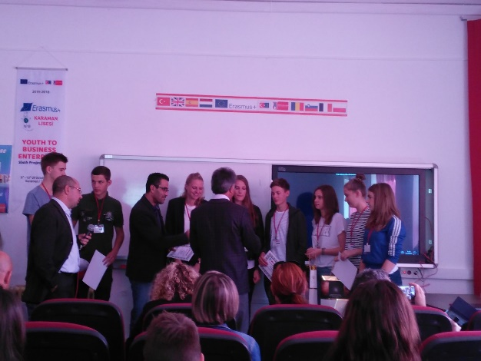After that there was an ceremony where everyone got a certificate and presents. We said goodbye to our friends. In the afternoon we had free time, which we spent with the Dutch people and their hosts.

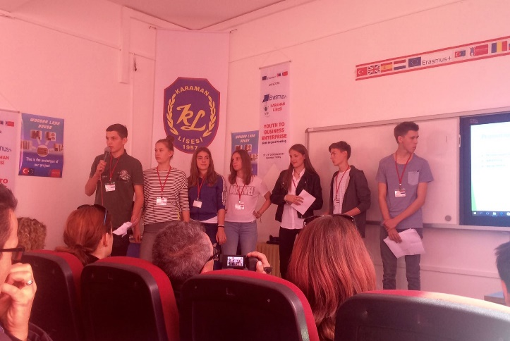

**Monday**

The headmaster said hello to us at the school and that he wished us a good week and a good time at the school. There was a teacher who translated everything he said because the headmaster didn’t speak English. We were showed the entire school. The school was compared with the Netherlands very white and not decorated with posters. After that we had to do our presentation. Our company is a cycling app. Foreigners can learn how to ride a bike.

There were groups of 7 made. Every person was from another country. This was a very nice opportunity to talk English with other children. I spoke a lot with an English boy and also with a Romanian girl. The group was very nice. In the beginning it was quite hard to communicate but it became better. We did a city tour of the great city of Karaman. We went to the castle and to a museum.

We were given a challenge to buy two kilos of apples for the lowest price. It was a nice experience to walk there in the market and see all these sellers and buyers. We were not the best team but I learned a lot of this.

**Tuesday**

We went to the lake of Ermenek. It took a while before we arrived because there were some problems with one of the busses. We went to a traditional factory. They did everything by hand and it was nice to see how it was made. After that we went to the lake for a boat trip.

After lunch we were given a few books of the surroundings of Ermenek. It was very blue water and a beautiful view in the mountains.

**Wednesday**

We had to buy Simits in the bakery. We bought 15 simits for about 9 Lira. That is very cheap compared to the Netherlands. We sold them at another school. For more than 2 Lira each. The profit was very big. We learned how to sell and how to make your project special.

We went to the university of Karaman and we were given a presentation about sale. It would be much better if we had this presentation before we had to sell these simits but it was still a very valuable presentation. It was about ways to make your project easier to sell.

We went to a very delicious cookie factory. We were showed the production line and we could eat as much as we wanted. We learned that research is an important part of developing a product.

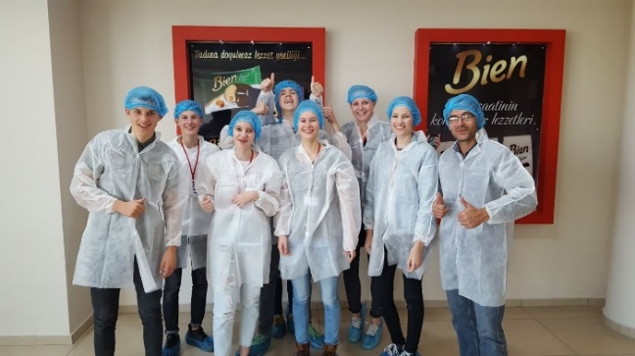

In the evening there was party. Everybody danced and the group became closer.

**Thursday**

We went early in the morning at 6 am to the sea. We did an awesome trip on a pirate boat. We swimmed and danced and it was a nice atmosphere. In the evening we ate at traditional restaurant.

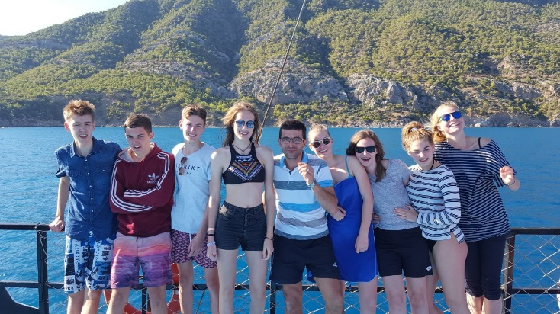

**Friday**

We had presentations about the workshops we did and there was an emotional goodbye moment. After the school program was finished we went to a farm and there we were allowed to ride on a tractor that was really awesome. We went back to Karaman, we did some go-karting and other attractions. It was a nice evening. Later that evening we went home with an amazing experience.

Jonne Hanning