Reports Dutch Students

Lisa van de Meehn

04-02-2018 So today was the day we were going to Slovenia. I had to get up at 5 a&apos;clock in the morning, way to early. My dad dropped me at Veenendaal de Klomp, where the KLM bus was picking us up. And there I meeted the teachers and my classmates. So we got in the bus and in an hour we arrived at the airport. We had to wait two hours at the airport before our flight to Graz. And I took pringles with me, and I dropped them at the airport, I was quite ashamed, so I picked them up and everyone was like looking at me. I was so ashamed. So when we were finally in the plane, we got a small bucket of water and a piece of cake. Our flight was 1 and a half hours long. When we finally landed, we took a taxi to Benedikt, and arrived there at 3 a&apos;clock in the afternoon. My host was not there when we arrived, so my teacher and my classmates ended up in a snowball fight. Than Vanesa, my host, arrived and she took me to her home. I met her mom, dad and sister: Tjašja. Later I went back to the school with Tjašja to pick Eliana up, a brittisch exchange student, who stayed at her house to. We ate, and later Issa, and Sara arrived at the house to. So our "club" was completed. I was very tired and went to bed. 05-03-2018 So Vanesa woke me up at 06:50!! What, thats like way to early, I normally wake up at 07:30 / 07:45 or something like that. We ate breakfast and missed the schoolbus. (Wich i&apos;n not used to cause in Holland we don&apos;t have school buses.) So her dad took us to school, I claimed the front seat, and they had to sit with 4 people in the back. When we got the school we had to make the "Holland Table" so we could present our country. Afther that we had to sing &apos;vijftien miljoen mensen&apos;. And after that, we had to to our presentations, our presentation was about Cycle Basics. And it went acctualy pretty smooth. So when "school" ended, we were going to Maribor. It was pretty awesome tho, there was this huge shopping mall. I had so much fun with Loeka. I bought this really cute shirt with "alone" on it. So when we wanted to go home, we missed the bus, so we went to a cute bar, and we bought drinks, while we were waiting for the next bus to go home. When we finally arrived home, I ate and afther that talked a lot with the girls who were staying in the same home as me, wrote in my jourey journal end went to bed. 06-03-2018 This day I had to get yp at 06:30 (as I said, to early) because we had to take the schoolbus. We went to Maribor with school to a "escape room" in the stone cold weather, for 90 minutes. It was so cold, and a borning in the begin, but after that is was fun. And at the and we were 5th of the 13 groups so not bad at all. When we were done with the escape room, we had to listen to a presentation about "how to
presenate". And my phone rang when it was all quit and stuff so I was ashamed, again. And after the presenation, we went to a restaurant to eat lunch. It was pretty good but just so much. When we were done, we got free time, so happy Lisa and Loeka :). I bought a couple of things and printed some photos. The evening after, was so much fun, we had a pjyama party, we sang all togheter, and it was so good. Like yass.
07-03-2018 Okay, okay, lets start with the point that I am so freaking tired. Like I havent slept a whole 8 good hours is days. And again I woke up at 6 in the morning! (Still way to early). We went to school with the bus ( that we didn&apos;t miss c: ) so the school bus dropped us at school, and we got our lunch and got in the bus to Ljubljana. But when we were on our way to Ljubljana, we stopped to visit, "Noela" a small company who makes creme with snail slime. Its pretty good tho, but the smell is like, ew. So when we were done by Noela, our trip to Ljubljana was continued. We had to sit on the bus for 2 hours. And when we arrived in Ljubljana we went to visit the castle of Ljubljana. It was pretty awesome and I took a photo with the dragon wings. We went to the highest skyscraper in Ljubljana to lunch, and the view was breath taking. Wonderful really. But, if you traveled to Ljubljana, to have to get back to. S 2 long ass hours on the bus back, and we finally got home. And I can finally sleep. 08-03-2018 Today, waking up at 6, eat breakfast, get on the bus to school, and sit in school. Today was like real boring cause we only worked on the presentations. I was teamed up, and we really didn&apos;t do much tho. So I got picked to speak to the radio, and it was so much fun, they asked me about the Slovenian language, and I said. "Well, it sounds like: jbjajajalallancnfkrkwkw" to me." And everyone in the room was laughing, but I was actually quite serious. I don&apos;t understand anything. Only "Ti si pizda" and "Jebi se" and both aren&apos;t quite nice things. So yeah hahaha. But after school, they my host family and the other girls went bowling, but I coudn&apos;t join because the bones in my back moved from place, so it quite hurts. So when they were bowling, I went to Lidl. Cause I missed these good breads. When they were done with bowling, we went to a restaurant and ate pizza it was actually good. Like i have&apos;nt taste pizza this good in a long ass while. When we got in the car to "home" I asked my mom, to look at the stars, so we would be looking to the same stars, cause I missed her. And it made me feel better. And when we got home, I called her and went to sleep.

Roos van der Horst

Saturday the 3rd of March, the day before departure:
As always, I started way too late with packing, buying the things that I need and doing the rest of the preparations. I have walked a few hours in Ede looking for some souvenirs. It is really hard to find something in this city. Eventually I found my souvenir and some typically Dutch sweets. That was the least I could do for the host family that is going to have to cope with me for a whole week.
While I was saying goodbye to my family, my little sister had to cry because she is going to miss me for a whole week. I am going to miss my whole family but I am also really looking forward to tomorrow and the rest of the week.

Sunday the 4th of March, the day of leaving The Netherlands and arriving in Slovenia:
I woke up at 4.50 AM and started by dressing myself. I checked if I had everything, said goodbye to my mom and left my house with my dad. We arrived at the train station where we would meet up with the students and the teachers. I said goodbye to my dad and together with the other students and the teachers we waited for the bus that was going to take us to the airport. The bus arrived at 6 AM.
At 8 AM we were waiting till we could get on the plane. We got through the security but not without a few little problems. Loeka still had some juice and deodorant in her bag. Mark still had his phone in his pocket while the security was scanning him. Lisa had some water in a bottle. Emony had deodorant and a very dangerous weapon with her, an umbrella. Mister Neidig was also pulled aside, because he had accidentally put a pair of scissors in his bag.
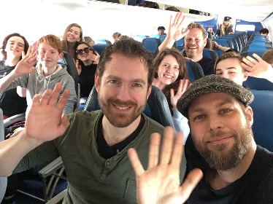
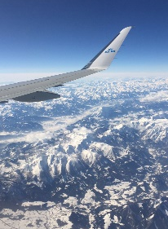
The plane was in the air by 10 AM. We were delayed for about ten minutes. Mister Kusters had brought an iPad with Fruit Ninja on it and we were taking turns playing it.
We landed at 11.15 AM in Graz. We had a very good flight. Somewhere during the last twenty minutes of the flight my ears plopped, so it became very hard to understand what other people were saying. After we landed we had our baggage within five minutes, that is a lot faster than at Schiphol. We had to wait fifteen minutes for the bus to take us to Benedikt, Slovenia.
At 1 PM we arrived at the parking lot in front of the school, where my host family was already waiting for me. We immediately left to go and eat lunch with Eva, her little sister, her parents and her grandparents. The food in Slovenia is delicious and everybody is super nice. But my ears still couldn't hear as good as they normally do, so sometimes it was very hard to understand what was being said. For the other side it was also not easy to understand what I was saying because I couldn't hear how loud I was speaking so I probably spoke very quiet. I ate as much as I could, maybe even more and we left.
Around 2 PM we arrived at the house, it was so modern, not even close to what I expected. Eva told me that her room was now my room, she would share her sister’s room for the week. Eva and I talked for an hour and we concluded that we actually had a lot in common. The actors we liked, the books, the movies, our hobby’s and on a lot of other things we had the same opinion.
At 5 PM we left to go to the mountain. We went up with a gondola and while we were going up we had an amazing view over Maribor. It was almost dark and the lights were beautiful. When we arrived at the top we couldn’t see a thing from Maribor because we were above the clouds. The clouds looked like pillows to me, probably because I was already very tired at that time. We went inside a restaurant to drink something and then went down again.
On our way to the favorite restaurant of my host family, I fell asleep in the car because I was so tired. Around 8 PM we arrived at the Italian restaurant. I got a pizza, it was enormous! I ate about three fifth of it and that was actually way too much. I felt so guilty that I didn’t eat the whole pizza but it really was too big for me.
When we got home I was told that I could take a shower. After that, we went to bed. It had been an amazing first day in this beautiful country.

Monday the 5th of March, the second day and the introduction:
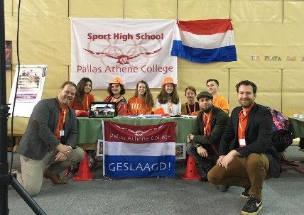
We had to wake up at 6 AM because we had to be in school at 7 AM. I was really nervous for this first day, also because I had no idea what to expect and how to act. When we arrived at school Eva had to prepare how she, along with the other Slovenian students, was going to present the introduction of the other seven countries. I, however, still had no clue about how this day was going to be and what was going to happen. I knew what we had prepared in Holland of course, our presentation, but that was all.
An hour later my teachers arrived and they told us what the day would look like. We prepared the last few things for our presentation and then waited for the program to begin.
It started with an opening, Slovenian students putting the flags of the eight countries in baskets, and people that were dancing. After that, each country was escorted to their own table. There was a traditional dance presented by eight children, including Ana, Eva’s little sister. Then all of the country’s presented themselves and their country. We, The Netherlands, did that with a short song, ‘15 miljoen mensen’. When each country was finished, we went to eat lunch in the school. The food was warm and we got it from the school, we never do that in Holland, we have to bring our own food to school.
After the lunch we would present how we were going to present our app, ‘Cycle Basic’s’. The presentation went well. I was very relieved because the hard part of the week was over now.
All the presentations were finished and we went to the classroom to get a workshop about how to present. We had to make a presentation about what we had learned and around 3 PM we could go home.
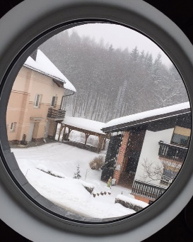
When we got home we heard that Ana broke her foot, so she had to go to the hospital. Eva and I drove with Ana and her mother to the hospital to get a confirmation that the foot was broken. Eva’s mother then dropped us off at the shopping center in Maribor.
We looked at clothes, tried some on and bought a few. We also ate something and continued by just walking, looking at stuff and mostly talking. Time flew by and before we knew it, it was already half past seven in the evening and Eva’s mother was there to pick us up to go home.
When we got home we went to the house of Eva’s grandparents, who live next door. We watched the photo’s that were taken from that day at school and then went home to go to bed.
This had been a very tiring but also very exciting day.

Tuesday the 6th of March, the second day and going to Maribor:
We got to sleep until 7 PM, at breakfast we ate pancakes and then we left for school. At the school we went to the classroom, we had to fill in a form about what we wanted to eat for lunch in Maribor. At 9.15 AM we drove to Maribor with the bus. When we got there the Dutch teachers started a snowball fight, children. Then we started with the assignment, the Escape Room. We received a book with locks on the pages. To unlock the locks, we had to solve riddles all over the town. When we solved them, we would get a number, the answer to open the lock. It was very cold and there was one puzzle the group I was with couldn’t solve. We had been standing in the freezing cold, in front of the riddle for forty-five minutes when we decided to ask someone for the answer. But by the time that we finally solved it, the time we had was already up, so we walked back to the meeting point.
When we got there, mister Kusters noticed that I was shivering, so he pulled a scarf out of his bag and a warm egg out of his pocket! I am still wondering why he kept it there.
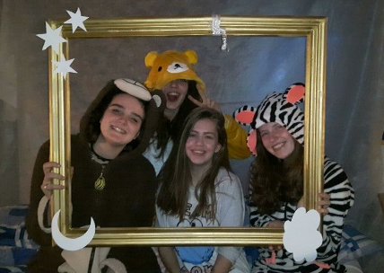
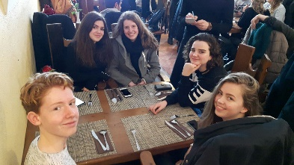
We went to a start-up company where a presentation was being held. It was a really good presentation, which makes sense because that was what the presentation was about in the first place, how to present. An hour and a half later, we went to the restaurant where we would have lunch. I am going to say it again; the food in Slovenia is really good. After the lunch we had a free period to walk or shop in Maribor. I was with Emony and Milo, we went to Müller and the H&M. And after an hour and a half we had to ran back to the bus because we were almost too late.
At 5 PM we arrived at school, where everybody started getting dressed, putting on their pajama’s. There was a pajama party! We danced with a lot of people for three hours, it was so much fun but at 11 PM it was time to go home and get some sleep, so that is what we did.

Wednesday the 7th of March, the third day and going to Ljubljana:
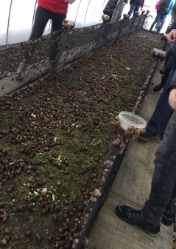
We had to be at school at 7 AM, so we woke up at 6 AM. The breakfast was, as always, very delicious. When we were at school we almost immediately left to go to a company, which is producing a crème for your skin, out of the slime of snails. We were allowed to go inside the greenhouse were the snails were kept. There were hundreds of them! Mister Stevens asked if he could pick one up, he was allowed and he picked up a snail, and just put it on his head. Disgusting.
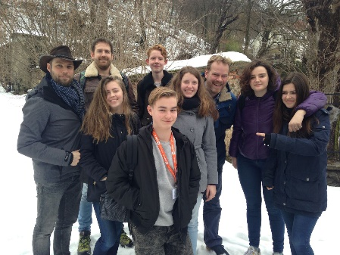
Within an hour we left to go to Ljubljana with the bus, it was a 2-hour journey. When we were halfway there I couldn’t find my wallet, so I assumed that it was still at home and that I would look for it in the evening.
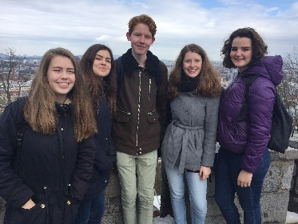
When we arrived in Ljubljana, we were guided through a part of the town, before we went up the hill to the Ljubljana Castle. Our guide told his story’s in a funny way so it was very pleasant and interesting to listen to. From the Castle we had a beautiful view over whole Ljubljana, we could see everything. It was amazing. We walked back to the city and made our way to the skyscraper, where we would have lunch. We climbed ten stairs to get to the top, where the food buffet was.
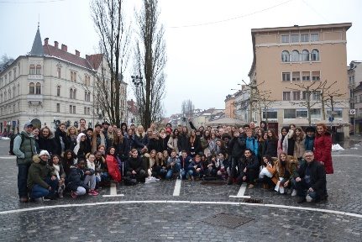
After the lunch, we had two hours of free time. So Loeka, Lisa, Milo, Sertac, Emony and I decided to shop for souvenirs. We had all found the things we were looking for and wanted to go outside to walk through the city. But it was raining so we went to the McDonalds to be dry, to sit, to warm up and to eat something.
The journey home went by very quick. It didn't feel like two hours at all. When we got home Eva and I talked for an hour or so. But then I remembered that I couldn't find my wallet earlier, so I started looking. I searched everywhere three times but it really wasn't there. I started to panic a little bit so I texted my mom, she told me to search again and to ask Eva and her parents if they had seen it, so I did. But they also hadn't seen it. At that time, I was sure that I had lost it, so the panic started to come because everything was in there, my ID-card, my credit card, my health- and travel insurance card and the card that says I can perform first aid. Eva’s parents reassured me that everything was going to be oke and that we would ask the teachers in the morning what we should do, but that there was nothing we could do now, so the best thing we could do is to go to bed.
I texted mister Neidig that I had lost my wallet and that I didn't know what to do. He called me right away and we concluded that I wasn't allowed to fly without my ID-card but that everything was going to be oke and that we would come up with a solution in the morning. With that in my mind I went to sleep.

Thursday the 8th of March, the fifth day and walking through Benedikt:
I woke up at 6 AM so I had an hour to think about what was going to happen this day. We ate breakfast and went to school fifteen minutes earlier, so we had the time to tell the teachers what was going on. The teachers were going to call the bus company that transported us to Maribor and Ljubljana because my wallet could still be in the bus. They also told me that everything was going to be oke. If nobody would find it then we would drive to the embassy and get an emergency passport so I could fly home on Saturday.
The program started at 8 AM with two presentations of company’s on how to present. At the beginning it was very interesting but I started to lose my focus along the way. During the presentations, mister Stevens asked me to come outside the classroom, there was a solution for my wallet problem. He had been talking to my mom and she was going to send my passport to Slovenia.
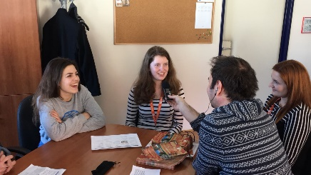
When the presentations were finished we had to start preparing our own presentation that we would give on Friday. It had to be about Slovenia in general, Maribor, Ljubljana or these subjects combined. In the middle, Emony, Lisa and I were pulled out of the class to give an interview, which was going to be broadcasted on the radio. It went really well. When I got back to class we only had a few more minutes left before we were going to lunch.
At 2 PM we got home and Eva and I watched a movie together. After the movie Eva’s mother took us to the police station. There we would have to get the official forms that I had lost my ID-card, so I could get a new one in The Netherlands. The police didn't have the form and told us to come back the next day. We went to the store and Eva’s mother bought me a new wallet. I tried to convince her that she really didn't have to, but she had already made up her mind. The wallet is beautiful.
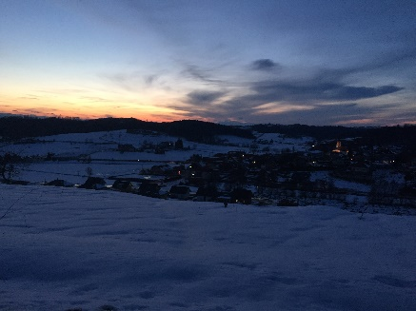
When we got home I called Larisa, the girl that was with me two years ago, when The Netherlands hosted the exchange. So, we agreed to meet at a bakery in Benedikt. It was really nice to see Larisa again. We talked for forty-five minutes but then we had to go.
Eva gave me a tour through Benedikt, we walked for an hour. The sunset was amazing, the sky turned into all these beautiful colors. Benedikt is a very cute town.
When we got home we ate dinner, watched another movie and eventually went to bed. I could go to sleep very peaceful because it had been a wonderful day and I knew that everything was going to be alright.

Friday the 9th of March, the sixth day and the day of goodbye:
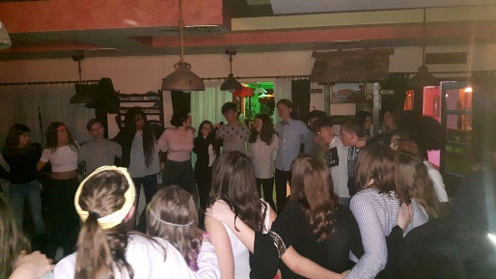
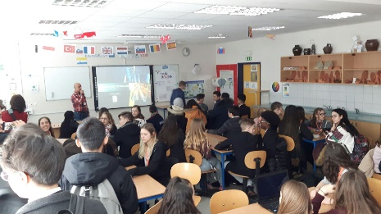
We woke up at 7 AM and got ready to go to school. While we were finishing our presentation at school I was asked to go to the police station with two teachers to get the right papers. We got them without a problem, went back to school and a little while later presented the presentation to the rest of the group. We were all very nervous but eventually everything went well. When every group was finished we were done for the day. Lunch was being served in the school but Eva and I decided to go out and eat in a restaurant. We walked there and ordered a hamburger. I expected to get a ‘normal’ sized hamburger but it was twice the size that I could have imagined. It was delicious. When we both finished our burger, we walked home to go and get ready for the ‘goodbye party’. I got a text from my teachers, it said that my passport had arrived at their hotel. I was very relieved. I started packing my bag with all the things I wasn't going to need anymore, I was finished and a few moment later we ate dinner and left for the party.
When we got there, I noticed that everybody was wearing some of the nicest clothes they own. I was really underdressed, I was wearing a very big sweater. Embarrassing. We danced and danced and it was so much fun, it was very hot but I had an amazing time. It was great but then the last fifteen minutes of the party came and I realized this was goodbye. At first, I thought I wasn't going to cry but Eva’s eyes started to get wet and then I couldn't help myself either, it was very overwhelming. We just stood there for ten minutes, crying in each other’s arms. Then we started saying goodbye to other people. Some time later a few teachers started singing sad songs, and they told us to go home. A few minutes later Eva and I went home. I said goodbye to Eva’s father because he had to work Saturday morning and wouldn't see me anymore. After that Eva and I went upstairs and we talked for a bit. Then Eva’s mother and sister came into the room. They gave me a bag with gifts in them. This family has been way too sweet to me. Eva gave me a bracelet with a heart on it. It was beautiful. I miss these people. After a lot of hugs, we all went to bed.

Saturday the 10th of March, the day of departure:
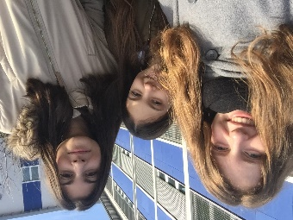
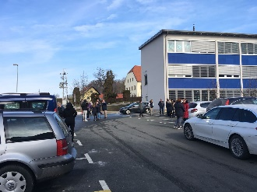
I woke up in Eva’s bed for the last time. I got dressed and ate breakfast. Eva’s mother gave me water, bread and some cookies for my travel. I went upstairs to pack everything and a few moments later we were on our way to the school where we would get picked up by two little busses at 8.30 AM. We got there at 7.45 AM so we had forty-five minutes to say our last goodbye’s. It was very hard to imagine that I would not see these people in a very long time or ever. At 8.45 AM it became clear that the bus would be late. So, we had a little bit of extra time.
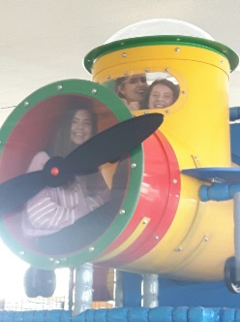
We had been saying goodbye for an hour and a half when the bus arrived. I hugged Eva for the last time and got on the bus.
We arrived at the airport and went through security. When all that was left to do was wait we started to play in the playground. When we got back to our seats my teachers said that the person that could show them their passport, could get a piece of chocolate. Of course, everybody looked for their passport immediately. But I couldn't find mine. Instant panic came across me. My teachers were looking at me because I was the only one left. They asked me where I left it and I told them that I had left it at the seat but that it wasn't there anymore. Then they handed me my passport. They had taken it to teach me a lesson to never leave my passport out in the open because it is worth a lot of money. I was super relieved but felt quite stupid.
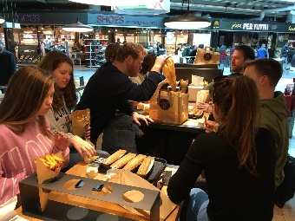
The flight was without any trouble and around 2 PM we were sitting at Schiphol, eating fries. We took the bus to the train station where our parents were waiting for us. I hugged my parents and said goodbye to everybody. In the last minute that I was there I heard that Mark had forgotten his jacket in the bus. But there was nothing I could do about it so we drove home. In the car I was telling my parents about my wonderful week, my dad was driving but he was also listening to my stories, so he accidentally forgot that we had to take a byway and we drove the wrong way.
But when we were driving, we saw the bus that had driven us to the train station. The bus where Mark’s jacket was in. We decided to follow it. We called Mark to let him know that he didn't have to call people anymore because we almost had his jacket, he thanked us and said he would pick it up at my house. When the bus stopped, we stopped as well, told the driver what was going on and got Mark’s jacket. It was a lucky accident and a fitting closure from this spectacular week.

I can’t thank the people I have spent this week with enough. Thank you all so much, it was amazing!

Milo Kronenburg
Report about the exchange to Slovenia

Day One in Slovenia (Sunday)
At half past five, I arrived at the train station of Veenendaal because that was the place that we would take the bus to Amsterdam Airport. After waiting a while, the bus came and we waved goodbye to our parents.
Once arrived at Amsterdam Airport, we went though the security checks and then to the airplane. It was a flight of only one hour and a half so I had to finish my episode of Sherlock on the airport in Graz. First Lisa, Loeka, Roos, Mark, mister Kusters and mister Stevens went to Benedikt with the taxi and we followed later.
When we arrived at the agreed place to meet, Filip was already waiting for me with his father on the parking lot. Filip’s father then drove us to their house on the top of a snowy hill. I was welcomed warm fully by the whole family and later we had a warm lunch together.
That day Filip and I did some games and we sled of the hill. In the evening I lay in a bed which was prepared for me and I slept wonderfully.

Day two in Slovenia (Monday)
At half past six, my alarm clock went off and I took a shower. After breakfast, we went to school with Filip’s mother.
First, I was toured through the school by Filip and later we went to the openings ceremony. People were dancing and singing and after that we had to go to our stand. Every country had to do an act and when our national anthem went, we had to sing ‘Vijftien miljoen mensen’.
After all of the acts, we could walk around and look at the stands. The French made salty caramel toffees so I enjoyed a few of them.
Then, we had a lunch break and after that the presentations. When we rounded up all of the presentations, we had an workshop about presentation techniques. After that we were finally done and could leave the school.
After school it was really fun because we went bowling with Lana and Emony. It was a fun night and I even won a few rounds.
For dinner, we went to McDonalds and we happened to meet Emony and her host family again.
After dinner we went to the new home of the sister of Filip, which was in Lenart.
At about nine o’ clock I went to bed and I soon went into dreamland

Day three in Slovenia (Tuesday)
Today we will go to Maribor I heard from Filip. That is why we had to awake fairly early in the morning. After a shower and breakfast, we went to school. When we arrived at school, we had to sit in a classroom for an hour and all we had to do was fill in a list with what we wanted to eat for lunch. Then we had to go on the bus to go to Maribor. It was a bus trip that took a while but we finally arrived in Maribor and there we were given an explanation for the escape room. The idea was that we would go in groups and we had to solve puzzles in the city center. At twelve o’clock, we went to a thing called a business incubator. It was a presentation of a young man who told us about presentation techniques.
Then we had lunch in a restaurant and some free time. First we went to a recommended shop but it was a disappointment. The girls wanted to go to the H&M so I followed them. Then it was already time to go back to the bus.
When we came back at the school, there was a pyjamas party. A hall of the school was renovated into a dancing floor. There even was food in a classroom next to the dancing floor.
At 20.00 the party was over and we went back home.

Day four in Slovenia (Wednesday)
This is the day that we will go to Ljubljana but before that, we will go the snail farm of the business of the sister of Filip, Noela. We went with the bus to the snail farm. The bus was too big for the small road to the farm so we chose to walk. It was a fun stroll of about two kilometres.
We all gathered in front of the farm and there we listened to the sister of Filip who told us about the business and how they started. After Filip’s sister was finished with the talk, we could look at the snails and then we went to Ljubljana.
In Ljubljana we were first guided by a guide though the city center, then we went with a funicular made of glass to the castle on the hill and we were guided some more.
The tour ended at the foot of a very tall skyscraper and we chose to climb it with the stair instead of waiting for the elevator. On the highest floor of the skyscraper was a diner waiting for us and there we had lunch.
After lunch we went to a square with a church facing it and after the group photo we had free time. In a group of about eight people we went though the city and we did some sightseeing and we bought souvenirs. Then we went to McDonalds to sit and talk.
At a quarter before five we had to be back for the bus but we were back at half past four so we were a bit early. We went back with the bus and then we went home.

Day five in Slovenia (Thursday)
Today will be all about presentations. When we arrived at school, we had to sit in the classroom and we had to listen to a presentation. It was given by a young man with a faulty English accent so it was very hard to understand what he was trying to tell us.
Then we had a short break. Before I even realized it, the second presentation had already begun. Everyone suddenly stood up and tried to see what was happening. I am still not very sure what happened because all I could see was that a man with a strange mask was breaking a croissant in half and put some milk in the same cup as that croissant.
The man finally removed his strange mask and introduced himself and his business. It was a business about engraving chocolate. It was another less-interesting presentation and at the end he gave us all a small chocolate.
Then we had a snack break and we were given some food in the canteen. After the break we had to work on presentations for Friday we had to do. We chose to take Maribor as a subject for the presentation. After some brainstorming and some making-the-PowerPoint we had some lunch and finally we could go home.
Filip and his parents then showed me some parts of Benedikt that I had not seen before. For example: the wells and the two churches. After the tour though Benedikt it was dinner time so we went to a pizza restaurant. That was my day.

Day six in Slovenia (Friday)
Today is the last full day in Slovenia and that makes me very sad. I hope that this day will be fun, to end this amazing week with a good memory.
When we arrived at school we had to go to the usual classroom as the past day. The first two hours at school we were preparing the PowerPoint for the presentation. Then we had a snack break and finally, the waiting was over, because we had to do the presentations. The presentations were in order of the group numbers and we were group two so we had to go second. Luckily, the presentation didn't go very bad. I was a bit nervous, but it ended up well.
After the presentations, we had to use our phone to fill in an evaluation online. It was a short evaluation but the organisation thought that it would take longer thus we had a long break before the end cermony. Every country had to come to the front of the classroom and then the certificates were given and a picture was taken.
Then we had lunch and finally we were free from school. We had arranged with some people to go to a cafe so Filip and I went there and met them there. It was a fun time where we had a glass of soda, played darts and went to a supermarket. then we went home, had dinner and went to the farewell party.
It was an amazing party and it had a very emotional ending where almost everyone had to cry. The party ended at about eleven o'clock and Filip and I were picked up by his father. I hardly slept because of the thought that I would leave the next day.

Day seven in Slovenia (Saturday)

I woke up early in the morning so that I could pack my suitcase for the trip back. After breakfast, we went to school because that is where we would meet with the other Dutch people. The taxi was delayed so he arrived more than an hour late. The flight home was a fine trip with a bit of turbulence. At Schiphol airport we had some chips and a frikandel and then we went to Veenendaal with the bus. In Veenendaal we said goodbye and we all went home.
This was an amazing experience and it's unfortunate that it is over.

Mark Bakker
Slovenië 2018
Day 1, March 4th:
5:45: We had to be at the trainstation Veenendaal-De Klomp at this time in the morning, because our bus would leave at 6:00. Al sleepy and packed up for our long journey, we kissed and hugged our parents goodbye. No one was really sad, but that wasn't weird because we were about to spent a week in Slovenia and make loads of new friends. The mood was good, really good. After a while in the bus and some spilled quark we arrived at Schiphol. After arriving we had to check-in. As soon we checked-in we went to the gate. We agreed to meet up at the same place in 45 minutes.
After 45 minutes of talking and walking around Schiphol, we met at the same place. Because we arranged some time to search for our ID cards and boarding passes and because our plane was 10 minutes late, we spent another 30 minutes at the gate. After these 30 minutes, it was time to board. The crew in the place was really nice and kind, we even got an passport holder.
90 minutes later we arrived in Graz, at the airport. After getting our bags, which went really smoothly, we waited for our bus to Benedikt. Next thing we knew, we hopped into the bus and went on the trip to Benedikt. Arriving at the school some of the host families were already waiting on us. And so was mine. After saying bye to the other students and the teachers, we went to the house. That afternoon we ate a lunch and than we talked in the living room. Later that evening we went to a bar and met some oher students. After spending like 3 hours talking in that bar, we went home and watched some tv. Around 22:30 I went to bed.

Day 2, March 5th:
I woke up at 6:30. Sleepy and happy, we went to the school. I hung out with the Dutch kids and talked a bit about our presentation. At like 9:15 the Welcome Ceremony started. After a nice performance from the Slovenian kids, it was time for the countries to perform. After our beautiful singing, we had a snack at school. Next up: presentations. After some nervous minutes we were one of the last groups to go. We were pretty good, according to the teachers.
Later that morning we had a presentation from mr Laing from the UK I believe. Last school thing that day was the lunch. In the afternoon we went to Maribor with some hosts and some exchange students. In the evening we didn't do much, just talking in the tv room. I went to my bed at 23:00.

Day 3, March 6th
Standing up at 6:00, I stuffed my bag with the onesie and a lunch. After doing my hair and eating a breakfast, we left the house and walked to the school. We arrived and hopped on the bus a gew minutes later. We were going to Maribor. Arriving in Maribor, we started walking towards the Ecscape ‘Room'. A couple of minutes and a lot of snowballs from the Dutch teaxhers later, we started the Escape Room ‘Unlocking Maribor’. It was a lot of fun! After being the 3rd group arriving, we waited for the other froups to arrive. Soaking in our shoes form all the snow, we walked towards our second presentation of the week. We listened to the good speaker and later got pir well deserved lunch at the restaurant ‘Rotovž'. I ate my spaghetti and enjoyed the free time. Being pretty wet of all of the thrown snowballs, we arrived at the school again. I quickly changed clothes and put on my warm onesie. The party was really fun. Only bad thing was the fact that my phone broke.

Day 4, March 7th:
Today we went to Ljubljana, but first we were going to a snail farm. They made anti-aging creams out of snailslime here. After that, our bus took us to the capital city, Ljubljana. After some sightseeing and again some snowballs from the Dutch teachers, we took the funicular to the castle. It was a beautiful castle, that, assuming I will go back, I will surely visit again! We ate our lunch in the skyscraper, with a beautiful view. We had some free time. We spent most of it at the McDonalds. In the evening we didn't dp anythin thrilling. We ate some pancakes, watched tv and talked.

Day 5, March 8th:
It looked like today was gonna be a kind of broing day, because of the workong and the presentations. It actually wasn't that bad. The working was a bit annoying because there were about 3 people workong in our group. But we made a.pretty decent presentation. In the afternoon, we went to the house of one of the hosts.

Day 6, March 9th:
The last full day… Luckily I forgot to save the presentation the day before, so I had to make a new one. The presentation went well eventhough we had made a totally new one. At the handing out of the certificates, our teachers cheered up the mood. After lunch we went home and got ready for the party. Eventough a lot of tears fell, the party was amazing!
That night we thought back to this amazing week with the family and we went to sleep at 1:30.

Loeka Beckman
Slovenia 2018
04-03-2018
Our journey begins. I needed to get up really early (5am), because the bus would arrive at 5.45. It was really cold and to early!! It was a one hour drive with the bus to the airport. We were there around 6am, while the plane would leave around 9am.
I had never been to Schiphol, it was really different from what I expected. The plane had a bit of a delay, but it was fine.
It was my first time flying, so I was a bit nervous. But it was actually really okay and the stewardesses were really nice. When we were on the airport of Graz we waited for the van to arrive who would take us to Benedict.
And that was a 1,5 hour drive. When we arrived a couple of hostess were already there but not mine. There was snow everywhere so we started a snow fight with the teachers.
Then Kaja came (my host) and we went to her apartment and I got something to eat. I went to bed early, I was really tired from the journey :)
05-03-2018
I needed to get up at 6am!!! Too early for me. We were at school around 7am while the ceremony started at 8am so we were really early. And the gym is huge , like just as big as the school itself.
Every country needed to present himself so we song a Dutch song, we were on TV and we tasted food from other countries.
We also got a presentation about body language and how to present yourself, It was very interesting. In the afternoon we went with a bunch of people too Maribor, we went shopping in the shopping mall Eurostar. Then we went to a bar and drank something and then we went home around 7pm. It was like a 40 minutes’ drive with the bus.
06-03-2018
Today we went to Maribor with school. At 10 o’clock started the escape room. But this was a really weird escape room, because you didn’t get locked up in a room you needed to go through the city and solve puzzles with a weird book we got in the beginning.
We got a presentation from a man who was really good at giving presenting.
After that we went lunching in a restaurant, I got spaghetti Bolognese it was so delicious :). After that we got some free time. Lisa and I went shopping. In the afternoon I just stayed at home with Kaja.
The pajamas party started at 5pm, there was a lot of food and good music. I really enjoyed myself.
07-03-2018
Today we went to Ljubljana (that is so hard to pronounce). It was a two hour drive, a pretty long time. We lunched in a restaurant in a skyscraper. It looked really expensive and the food was really good!
Than we got two hours free time. We went with the Dutch team and a Turkish guy the city in. We mainly looked for souvenirs. And we went to the Mac Donald’s, because why not?
When we were finally home, I went with Kaja and her parents to the movies. The movie was really good. And there were so less people in the cinema. In the Netherlands a lot of people go to the cinema. I guess in Slovenia not so much people do that.
But we were at home around 11pm so I was really tired.
08-03-2018
Today we just went to school and listened to some presentation, with a group we made a presentation. We didn’t do much this day. It was actually really boring.
In the afternoon Kaja and I went eating Pizza with a friend of Kaja and a Turkish girl, she spoke Dutch so that was really handy, I really liked her.
09-03-2018
Today we listened again to a presentation, we needed to make a presentation about Slovenia and present that to the group. Again we didn’t do much.
In the afternoon we went with a bunch of people to a bar and drank something and played dart, it was really fun.
At 8pm the farewell party began. We danced with each other but around 11pm we needed to say goodbye to each other because tomorrow we would go home. They played really sad music and everybody was giving each other hugs, it was soooo sad :(. It think I cried for 20 minutes straight. When I started crying I just couldn’t stop.
10-03-2018
I needed to get up at 7am because the van would arrive at 8am. I already packed my suitcase the night before, so I just needed to eat and I could go. The van came an hour to late. So we stood there in the cold, we talked with each other (again I cried).
The journey back to home was sad and happy at the same time. I was (I still am) sad because there were amazing people and most of them I think I will never see again. But I was happy because I would see my parents at home and I would sleep in my own bed again.
I am going to miss these people so much. It was a great experience and I learned a lot of new things.

