Voorkant:

Y2BE Erasmus+ program Ede

March 2016

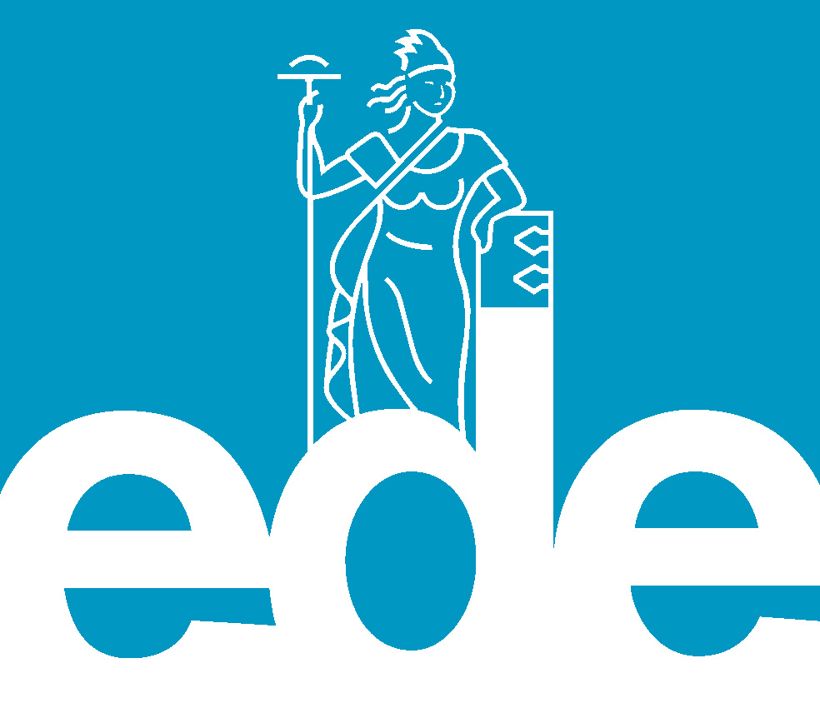

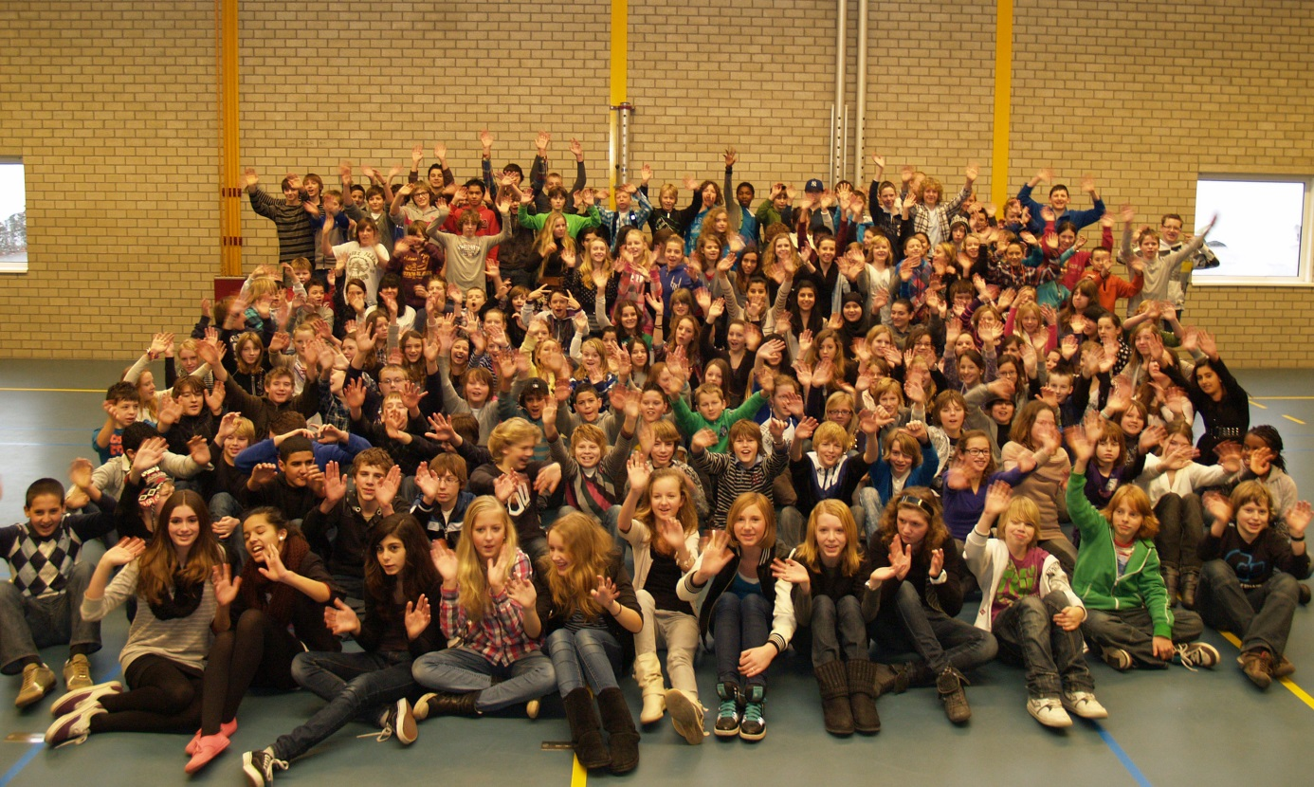

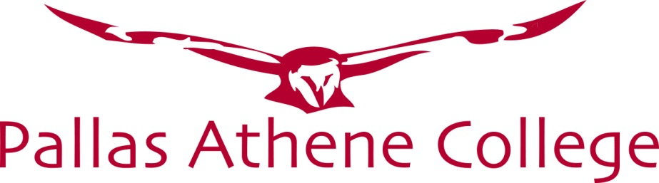

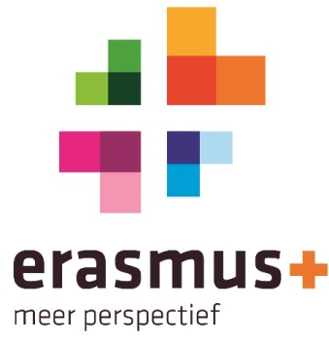

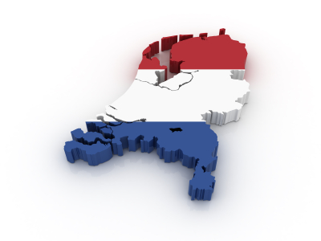

Welcome to the Netherlands,
greetings from Pallas Athene College!
Pallas Athene College is a comprehensive school with more than 1100 students. It is divided into three levels of education, the highest level being the pre-university education.
We believe that school is more than studying from books. Each and every student has special interests and talents. All students at Pallas Athene College have an opportunity to discover and develop their talents. This is the reason why we offer special interest classes next to regular subjects. All students sharing the same interests spend four hours a week in one of the following classes: Sports Class, Drama & Arts Class, Research Class, and Athene Class.
Sports Class: this is the place to get acquainted with many different sports. Team spirit and sport experience are the main pillars of the sports class. Pallas Athene College is a school with a sporting spirit.
Drama & Arts Class: painting, dancing, making music, acting, and even sculpture are skills students can expect to develop further in this class. A few times a year students show their progress and achievements through exhibitions and plays. In the 3rd year, students prepare and perform an entire musical.
Research Class: research in the area of science, design and technology is the main focus of this class. Being a good researcher requires a special talent. Taking notice of the world around you and wondering about it is certainly part of this special talent. Good cooperative learning skills are important in this class.
Athene Class is for students whose interests lie in the people around them, their environment, and their community. A mix of drama, sports and research skills are to be found in this class. Culture, science, sport, and media are main areas of interest.
Kind regards,
Pallas Athene College

Ede
The city itself is situated halfway between the larger cities of Arnhem and Utrecht with direct rail and road connections to both cities. There are no connections to any water nearby, however, there also is a direct road connection to the city of Wageningen which hosts a small industrial port on the river Rijn and a direct road and rail connection to the city of Arnhem, which features larger port at a greater distance. The environment is clean and green due to the fact Ede is partly built in a forest and partly on the central Dutch plains in the national park called Nationaal Park “De Hoge Veluwe”.
Socially, Ede is a common city like any other in the Netherlands. Each year, there is a municipality-wide celebration called Heideweek (Week of the heather) which lasts a week largely involves traditional Dutch festivities, along with local customs. During the week, a Queen of the heather and a Princess of the heather are elected from several candidates and will be the representative for the municipality of Ede on various other festivities, until next year when another a new queen and princess are elected.
Ede is situated along the A12 motorway and has a direct link to the A1 via the A30. Ede-Wageningen railway station There are two stations in Ede: Ede-Wageningen railway station and Ede Centrum railway station. Ede-Wageningen is the main station with services to Alkmaar, Amersfoort, Amsterdam, Amsterdam Airport Schiphol, Arnhem, Barneveld, Den Helder and Utrecht. Ede Centrum is served by trains from Amersfoort and Barneveld to Ede-Wageningen.

Where to eat in Ede
Some suggestions for a good meal in Ede:
- Juffrouw Tok chicken/Dutch kitchen
- Planken Wambuis Dutch kitchen
- De Verleiding Dutch kitchen
- Amadeus Steakhouse
- Het Pomphuis French kitchen
- Villa Brutus Italian kitchen
- De Chinese muur Chinees kitchen
- Dixies American diner
- Nok’s kitchen Tai kitchen

What to do in Ede
- National Park “de Hoge Veluwe”
- Krüller Müller museum
- Dutch tile museum
- Cheesefram Hoekelum
- Hoekelum castle
- Cinemec cinema

Contactinformation
Pallas Athene College Koekeltse Boslaan 21,Ede tel. +31 318 624500
International coördinator Joep Kusters tel. +31 644501590
Hotel De Paasberg Arnhemseweg 20, Ede tel. +31 318 651020

City map of Ede

Wellicht bruikbare afbeeldingen

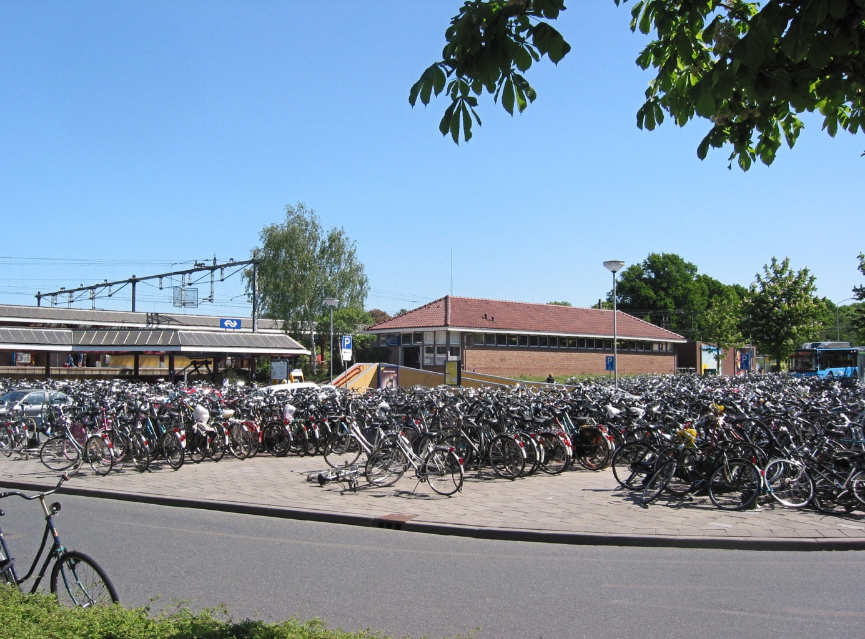

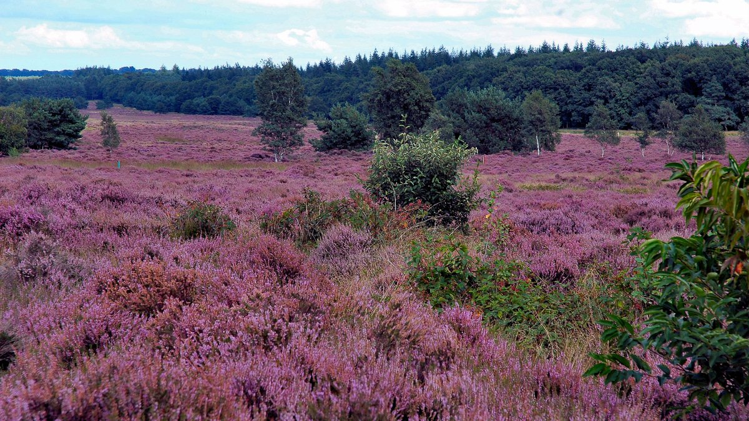

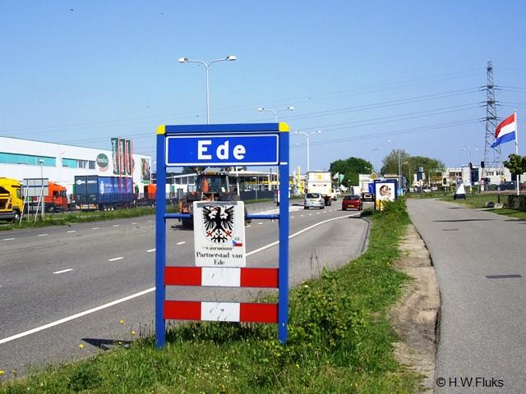

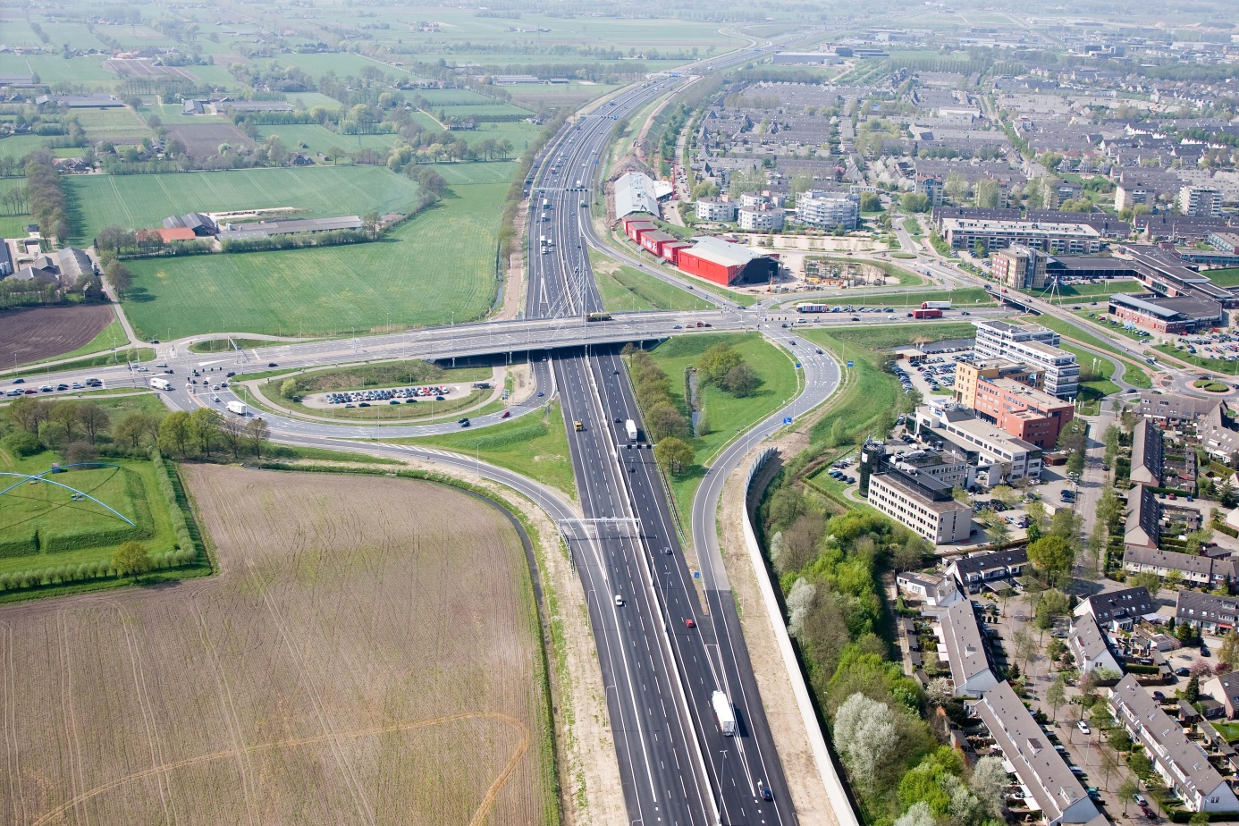

Nijmegen

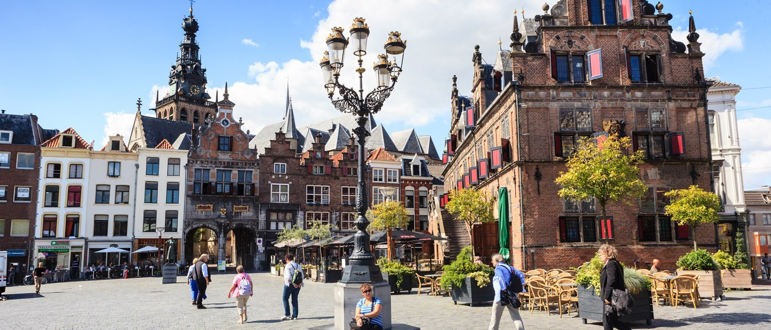

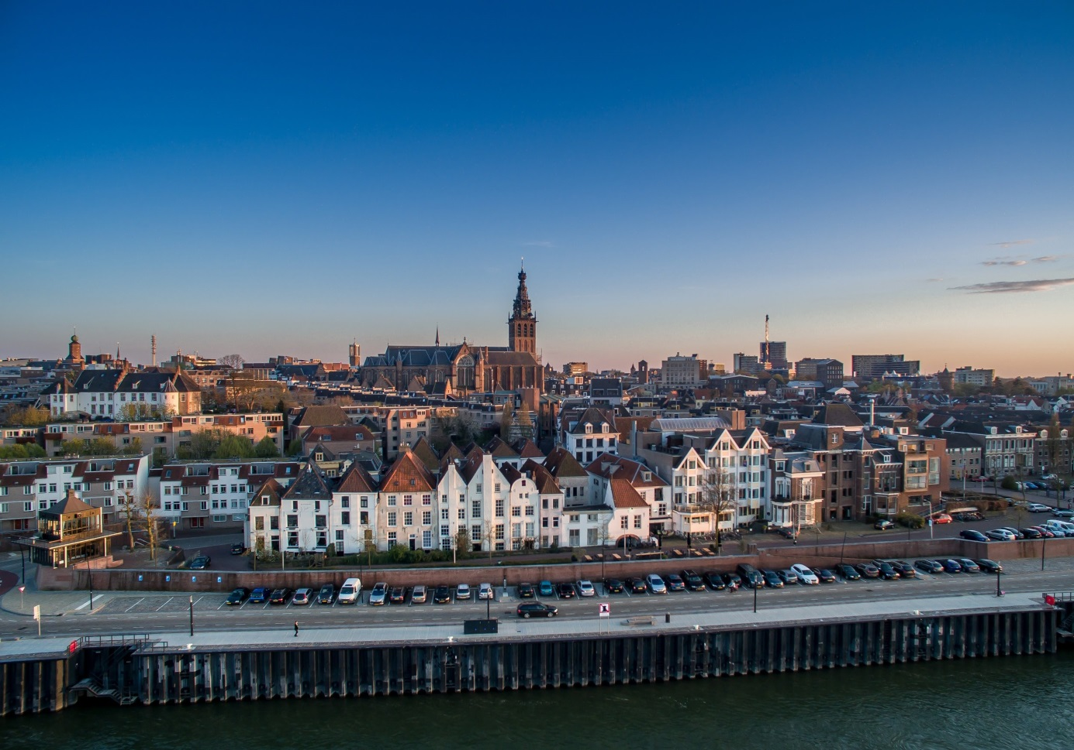

Vasim Nijmegen

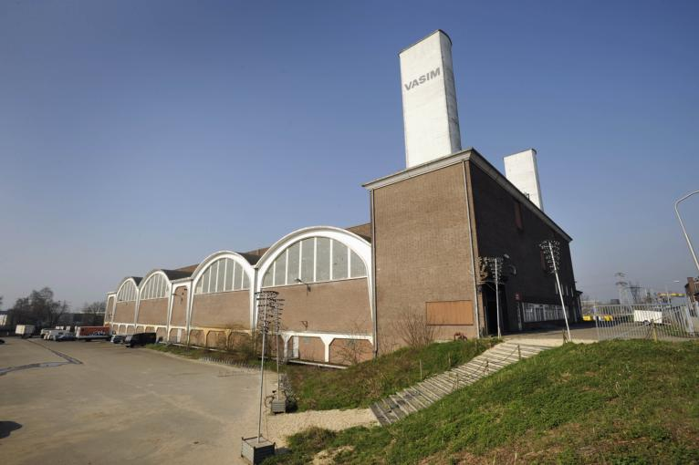

Honig Nijmegen

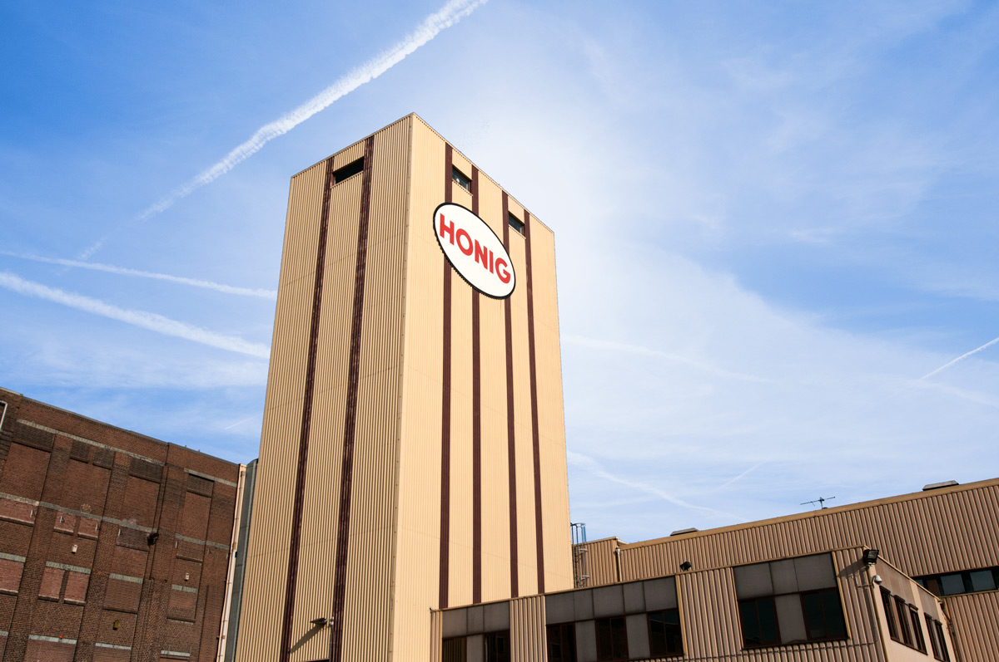

Kröller-Müller

