Dutch Reports Alicante Mobility 2016
Imke Verschuren, 15
Saturday the 15th of October
Today, we were going to travel through Alicante. We got on the train to the airport around nine in the morning and arrived in Amsterdam about an hour later. When we got to the airport, we immediately went to check-in. The flight itself took about two and a half hours.
When we arrived in Alicante we were picked up by our host families. After I got settled, my host sister (Marìa) and me went to Alicante with some friends to explore the city.
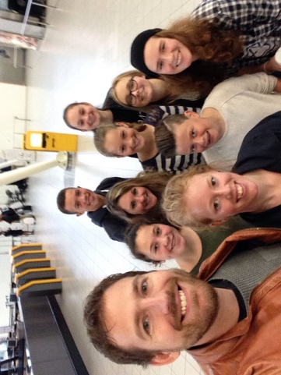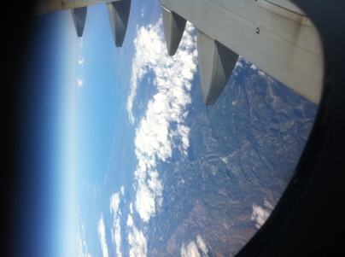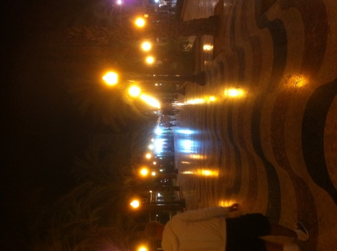

Sunday the 16th of October
We had a day off today, so we slept in and basically just had a very relaxed day.
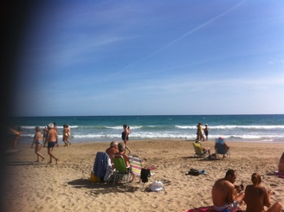

Monday the 17th of October
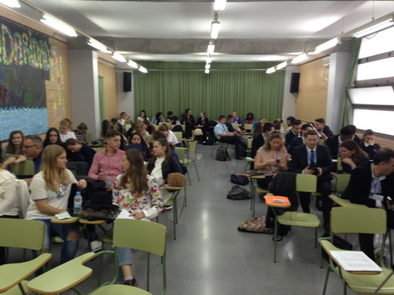
Today was the start of the exchange. We began with the presentations (after waiting in the classroom for about two hours) and got some more information about the exchange itself. We had a three-hour lunch break after that. When we got back from lunch, we started on the actual project: we had to design an alarm to warn parents when the water level in the bathtub got too high to prevent baby’s from drowning in bathtubs. We got a presentation about something called ACCESS FM, some sort of guidelines that we had to use to design our product.
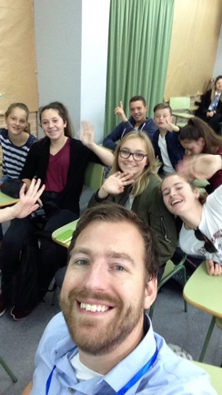
We got split up into different groups, all kinds of nationalities together, and started designing. Since our group was quite big, we were working on two separate projects at first (we didn’t actually realise we were all one group) but then we combined the best points about both products into one. I did the research about the environment, but I ended up deciding on the materials as well because I had done more in-depth research than my teammates searching for materials.

We went home after this.

Tuesday the 18th of October
On Tuesday, we went to Alicante to see the city. We took a tram to get there, causing the usually quiet tram to Alicante to be crammed with students speaking about ten different languages. We went to the archaeology museum of Alicante, which was interesting despite the mediocre guide and learned more about the area of Alicante throughout history.

When we finished the museum tour, we went to Castillo Santa Barbara. It was massive. We could go to the top of the castle with some of the Spanish students if we wanted to. The students told us a bit more about the castle and let us take pictures of the view which was magnificent.

Then we went into the town centre to walk around for a bit, but we had to hurry back to the tram station after about fifteen minutes.
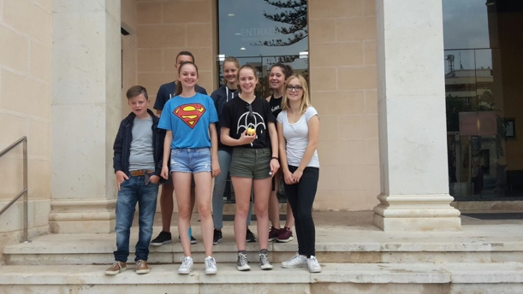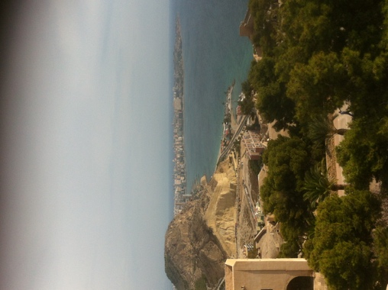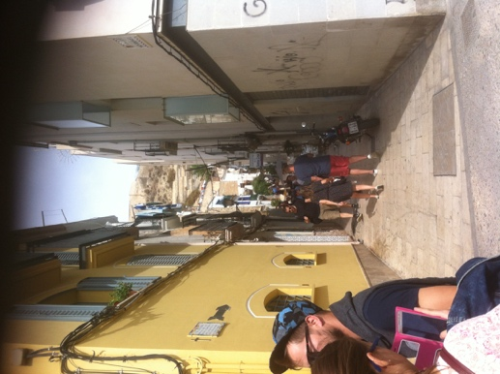

Wednesday the 19th of October
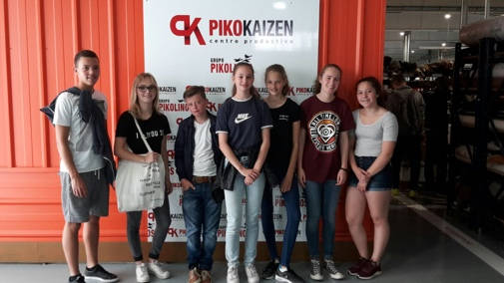
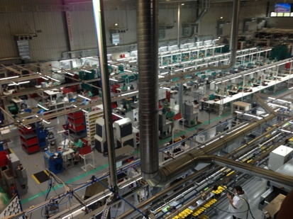
When we got to school on Wednesday morning, there was a very big fancy bus waiting for us to take us to Elche to visit a shoe factory. We got to see how the shoes were made and got a tour around the factory. We got to take a look at the people who worked there as well, but the work didn’t look very fun to do; it was very monotonous.

After a visit to the factory we went to the outlet store where we could do some shopping if we wanted, but the shoes were too expensive.

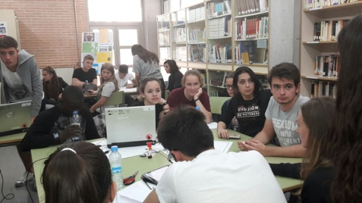
Then we took the bus back to the school and worked on the design of previously mentioned alarm. We started on the posters and worked out the details of the alarm. At the end of the day we had our design, an elephant, and we’d worked out how it was actually going to work and what it was going to be made out of.

Thursday the 20th of October
On Thursday morning the bus was waiting for us again. Today it drove us to a toy factory, once again in Elche. First, we got a tour of the design department and the showroom (which I thought was the most interesting part of the tour). I liked the design department because there was a lot of fancy technology and cool prototypes.
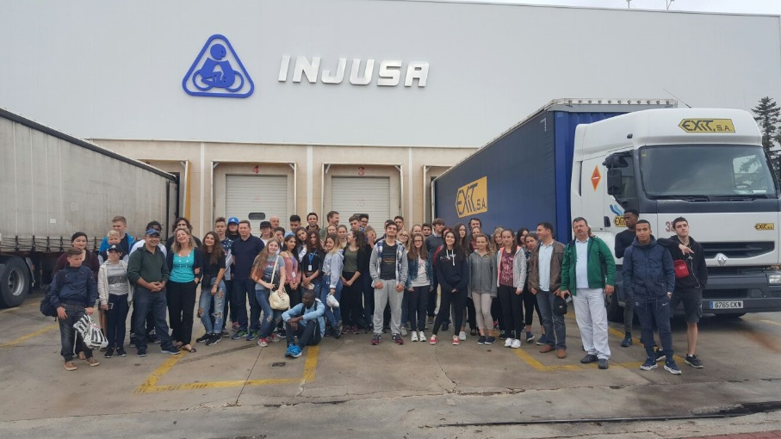
After that we went to the metal factory, but it was very tiny because most of the toys were made out of plastic. That’s why we didn’t stay there very long.
Then we went to the big factory where we got to see the actual toys come together. I really liked the little Mercedes’s that you could control with an app on your smartphone.

In the afternoon we went to a furniture factory. I liked that a lot because it smelled very nice and the tour was interesting. We went into the office buildings (really fancy) and tried out some of the furniture. We got a presentation after that, about the designing process. It was really interesting, but the WiFi-code was taped to the wall so a lot of people were paying more attention to their phones than to the actual presentation.
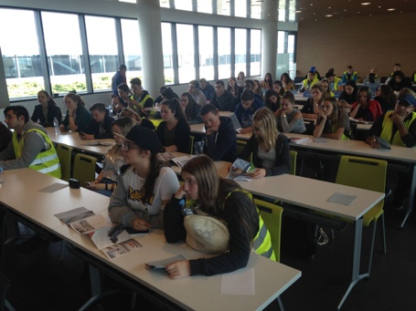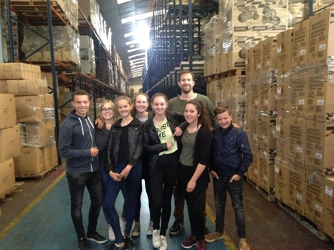

Friday the 21th of October
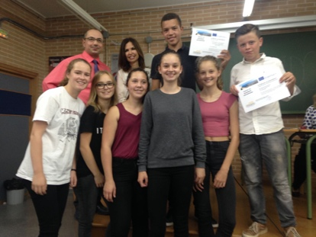
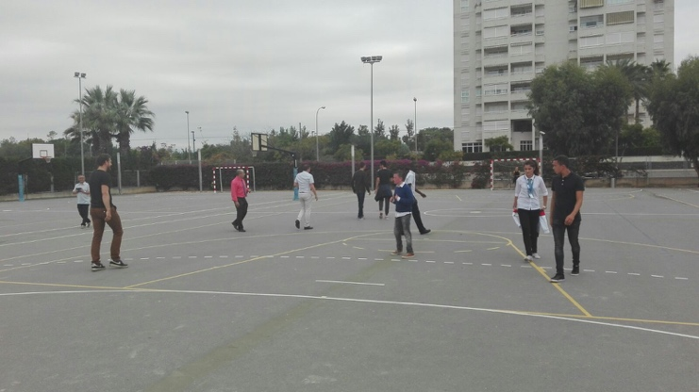
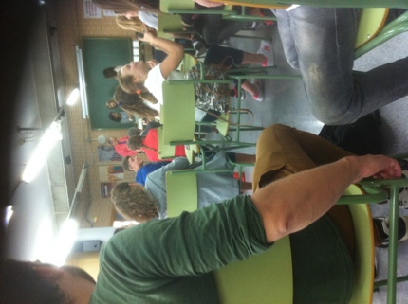
Today we had our final presentations. We got about three hours to prepare and practise and then we had to present them. After this we had another lunch break where we played football with some teachers. Then we went back inside and got our certificates. After the ‘ceremony’ we went home to prepare for the party that would start later in the evening, but we left a little early to go shopping for souvenirs and such in Alicante. There was an actual mariachi band playing in town, which was hilarious.

Saturday the 22th of October
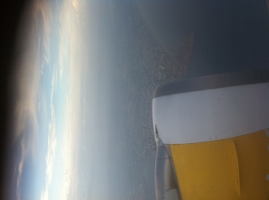
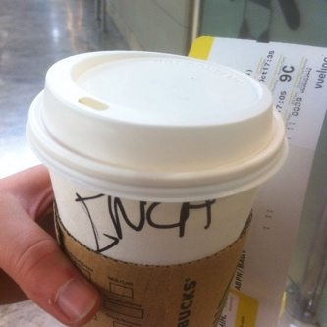
Today was our last day in Spain, so we went to the beach to say goodbye. It was really warm, so some of us went swimming. We were supposed to meet at the airport at 15.30 sharp, but almost everyone was late (Spanish culture I guess). After security we got some free time and I ordered coffee in Spanish, which I was very proud of because I didn’t really speak Spanish before we went (I asked my host family to teach me some Spanish). When we got back to the Netherlands, it was really cold (about three degrees, it was twenty-four in Alicante when we left). I was home just after eleven in the evening.
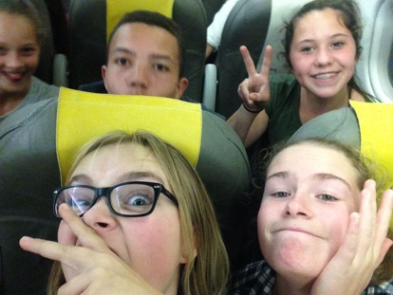
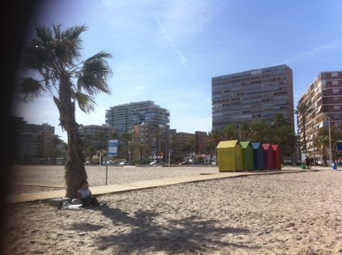

Floris van de Pol, 13
Alicante,spain

Saturday: exciting? Yes it was very exciting. Other people, other cultures and also the people there could not even English. Tension was sure this stress so also but I have at the end can say that I have learned some of Sunday. I have learned that I must come to rest ff when I have stress because they are all nice people
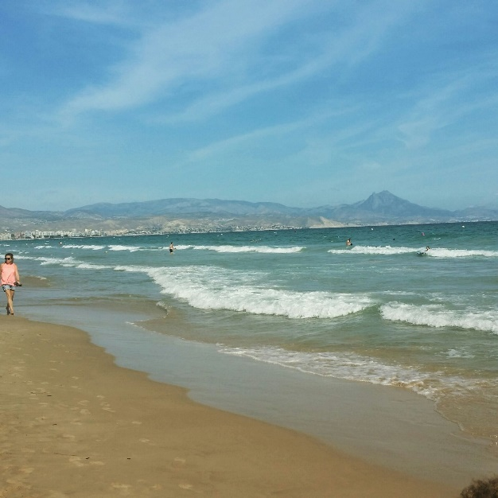
Sunday: the tension was there. So enjoy Spain because it is really beautiful. After that day was really quite tired
Monday: first day school. at last! Dutch talk to people you know, and learn new things. Finally not learned a lot. Because we had a break of 4 hours where we relax on the beach. But the culture was so different that I eventually may not be much in school but after school, that's another story. The culture was so different. Always a party many eating and lazing on the beach. Really quite different
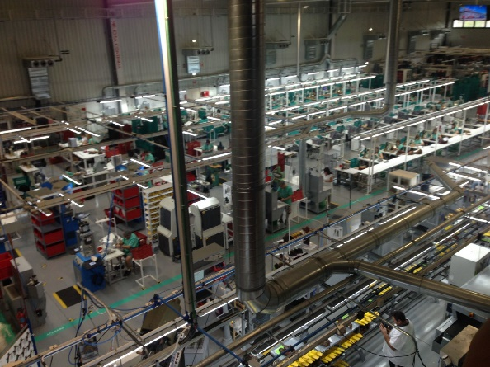
Tuesday: not much to say seems on Monday.
Wednesday We went visiting factories what I best boring was made.
Thursday: We got this day to learn what I don't quickly forget: ACCESS AM each letter stands for something and if you watch something on each is your product perfectly!
Friday: Last day at school. Tasty prepare for the presentations of our product. I worked with an English girl and went together and a few other really tasty. Good communications, good idea and a good result. In the evening we went with all countries in the city. And then we had to say goodbye to awkward but fine.
Saturday: home! Really enjoyed it!

Jasmijn Hanzen, 14
On Monday we worked on our project from acces fm. We worked on a frog that will sings if the water is too high for the baby so he won’t drown in the bad.
On Thursday we were to the castle of Alicante it was a long walk but it was it worth it was so beautiful the city from that height.
On the Wednesday we were to the shoe factory of pikolinis we saw there how they make the shoes in every piece that was really impressing.
On the Tuesday we were to a toy factory it was much complicated then I thought but I really enjoyed that. we also were to the furniture factory.

On the Friday we were going on with the acces fm and gave a presentation about our product. The people were interesting listening to our product the Froggie Frog.

That was my experience of the trip to Alicante
I thought that every country can talk English but that is the wrong mind.

Bente Bakker, 15

On Saturday, we left at 10 o’clock in the morning. We went by train to the airport with the 7 kids and our 3 teachers. Our plane left at 2 pm. When we arrived, at approximately 6 pm, we were welcomed by our host families and we all went to our temporary homes. I really enjoyed my first evening in Allicante, my host student, Martina, and I went to the city center and ate our dinner at The Good Burger. It was kind of weird to eat at 9 o’clock, because in Holland, we eat at 6 or 7 pm. On Sunday we did some homework and we went to the beach with two English Erasmus students and their Spanish host students.
On Monday we had our presentations about the market research. It took a lot of time, but some of the products/businesses were really interesting! We had a 3 hour break and all the Dutch students and our teachers went to the beach. At the beach we played volleyball with some of the Polish people. In the afternoon we had a workshop about designing a product. We learned about the ACCESS FM, which stands for Appearance, Costs, Costumer, Environment, Size, Safety, Function and Material. There were 6 groups made from all the students from the different countries. We had to design a product to help parents prevent their baby from frowning in the bath. We started looking for information and designing our small toy.
On Tuesday we had a tour through Allicante. We went to the archeology museum near by Allicante, I thought it was very interesting, but I didn’t understand everything from our guide tour. It was about the history, from prehistory till Greeks and Romans. After the museum visit, we went to the castle of Allicante on top of a mountain. We talked to a lot of students from almost all the countries and we really got to know each other, I really liked that. We also had a small guide tour through Allicante at the base of the mountain.
On Wednesday we went to the shoe factory Pikolinos. They showed us what their process of designing and making the shoes was. It was quite informative! We also went to their shop to see all the end results of their productions.
On Thursday we went to two other manufactories. First we went to a toy factory, they showed us their showroom with all their products. We went to an office, where they worked on designing the toys, which were mostly small cars for kids or playing houses. We also went to the factory, where the toys were made. We saw how it all started, with the small plastic balls and the malls that they made out of different materials. How the toys were made in small and bigger pieces, how the stickers were kind of printed inside the plastic and of course, how they put the cars all together. We also went to see their huge storage building with all the pieces of the toys. I thought that this factory was really interesting. We saw the entire process and I really liked it! After that, we went to a furniture factory. We had a look around the, very modern, building and they showed us their showroom. We also had a presentation about some of their newest products and how they designed it. It was really interesting, because she gave a very clear explanation. Their goal was to make an office a great place to work. They wanted to include some nature and furniture that makes you want to have fun, but also work. You could really see their goals in the products and I think that it was very informative and useful for our own process in designing a product of business.
Friday was the last day we had with the whole group of students. We finished our presentations about the bath toy and we presented our products to the other students. My group designed a Winnieh the Pooh toy that could check the water level and warn the parents if it is too high. The honey cup of Winnieh the Pooh checked the water temperature so the bath was fun and safe for the baby! In the afternoon, we had a small party at the school and afterwards we went to the city center with almost 40 students from the Erasmus project. I really enjoyed my visit to Allicante and I will miss everyone!!

Daphni Apostolakis, 13
Saturday 15 th October I left home and went to the train station in Ede. Then we took the train tot the airport. The airplain left at two o’clock. It was a good flight. When we arrived at Alicante the host families were all waiting. They were nice but the didn’t speak English very well. First we brought my suitcase to there house and then we went in to town. We had dinner very late. Sunday we visit friends of the host familie and had lunch there. Later we met other exchange students. On Monday we went to school at eight o’clock. We showed our video about cycling , and we watched the other presentations .Then we had a three hour brake and we went tot the beach. Then we worked on a project about waterlevels and babies. We learnt some handy things about access fm. On Tuesday we went tot he historical museum of Aclicante. After that we walked tot he castle of Santa Barbara. It was on the top of a mountain and the view was wonderfull. Than we walked back, we all went tot he beach. On Wednesday we went tot he shoe factory Picolinos. The shoes are hand made. It was interesting, but also a bit boring. Thursday we visit 2 companies. A toy factory and a furniture factory. It was interesting to see how they made toys. In the furniture factory we learnt about how the office work there. Friday was the last day at the host school and we had a lot of fun, We did our presenation. Then we had a brake and a goodbye. In the night we had a farewell party and it was nice. After the party we went with a lot of exchange students into town to have fun. Saterday we went tot he beach, and then we had to pack our things and we went tot he airport. We had an our delay but that wasn’t so bad. We arrived late at night in ede. It was a very nice exchange!

Delano Alberto, 16

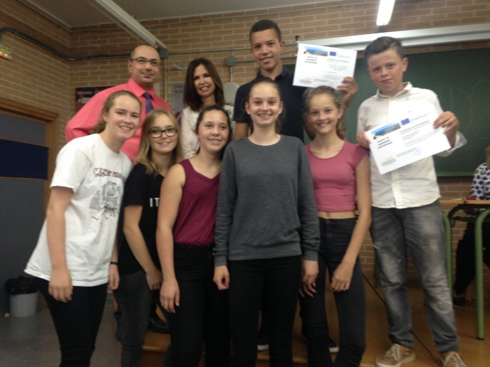
My Report on the exchange to Spain:

The experience was amazing and i’ve learned a lot.
We worked with ACCES-FM that is a system that entrepreneurs use.
This thinking-system has to help us make/design a product.
ACCES-FM is a great system and i’ve learn how to propely design a product.
We also went to a couple excursions, that were especially factories.
The first excursion was to a museum and there we’ve learned about trading and inventions.
The second excursion was to a famous factory named Pikolinos.
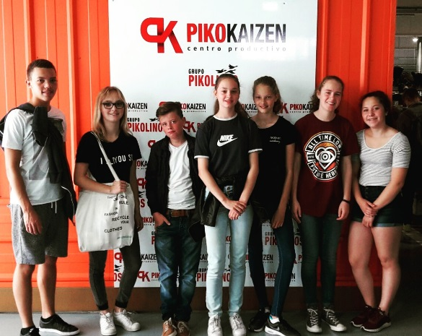
We’ve learned about making products handmade.
The third excursion was to a toy factory.
We’ve learned about making deals with bigger brands so you can still competitive against low-wage countries.
The fourth and last excursion was to furniture factory.
There we’ve about the importance of satisfying the imployees, because if you do that the customer will be satisfied to.
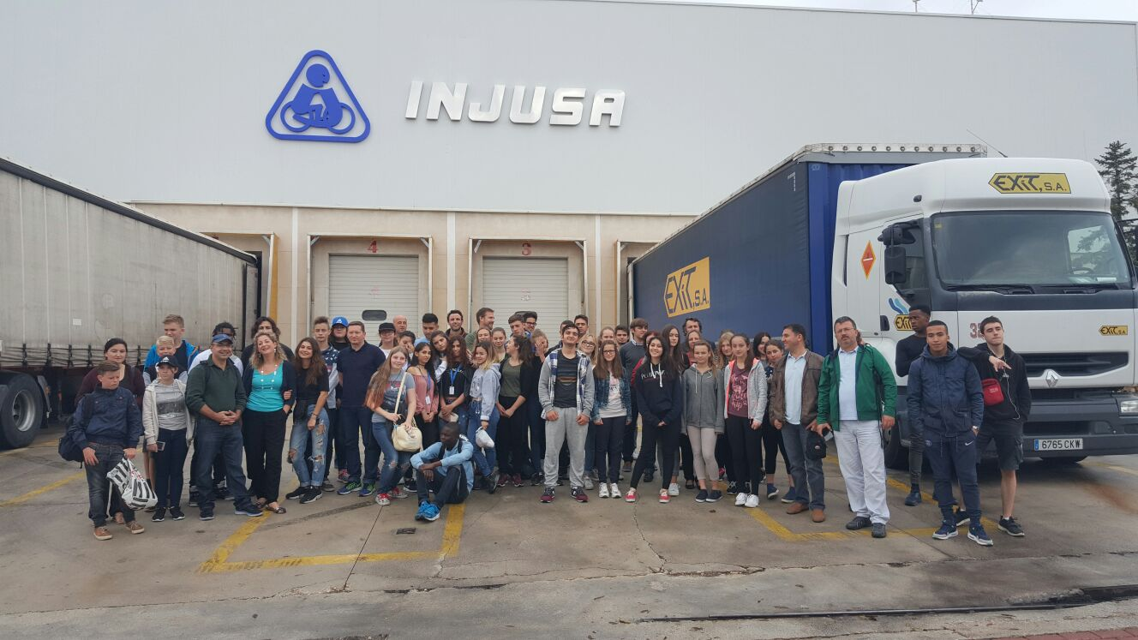

Amanda Hanzen, 15
Alicante exchange

On Saturday the 15th of October we went on an exchange to Alicante. As soon as we arrived at the station Ede-Wageningen we saw that almost everyone was on the platform to say goodbye to us, from family members to just friends. As soon as the train arrives, it stood there without moving an inch, after 5 minutes of just standing there everyone one the train got out, ‘cuz the train didn’t go any fader. There were so many people on the platform, who all had to pick the next train on the other side of it. Once inside of the train, we could barely move. Once we went passed Utrecht station, we could finally breath out normally and even a view of us had a seat. Once we arrived at the airport, we went passed the security and had 1 hour off until boarding. On the plain we were lousy and really loud. When we went off of the aircraft, the host family’s were already waiting for us to arrive.
On Sunday we had spare time.
Monday was our first school day, school started at 8 am. We first had to wait for the teachers to arrive. After that we had all the presentations about Alicante and other school, we had our idea presented in a video (Henk) after that we had 3 hours off, we as the Dutch people who almost never have a chance to go to the beach went to the beach. As we returned he had a presentation about ACCESS FM and got sorted into groups of all country’s mixed. And worked on our ACCESS FM until the end of the day
Tuesday we went to visit an archaeology museum and after that we met up at the beach
Wednesday we visited PIKOLINOS were miss. Hummelink bought herself new shoes. And went to a castle which I could walk by myself because it was on the top of a mountain. I got there with the help of Daphni and the bag carrier’s (: On the way down I lifted on the neck of sir. Kusters. ( it was so high) we took the train back to our home.
Thursday we visited a toy factory on 3 different locations, 1 was the factory, 1 was the office and one was where the leftovers from the factory went.
Friday we had our presentations about ACCESS FM. And in the evening we had a ‘party’

