Dear all,

When your students come to the Netherlands They most probably will use bicycles to drive from there family houses to the school. To give them a bit of an idea what to expect I have sent u this mail with some movies about biking in the Netherlands.

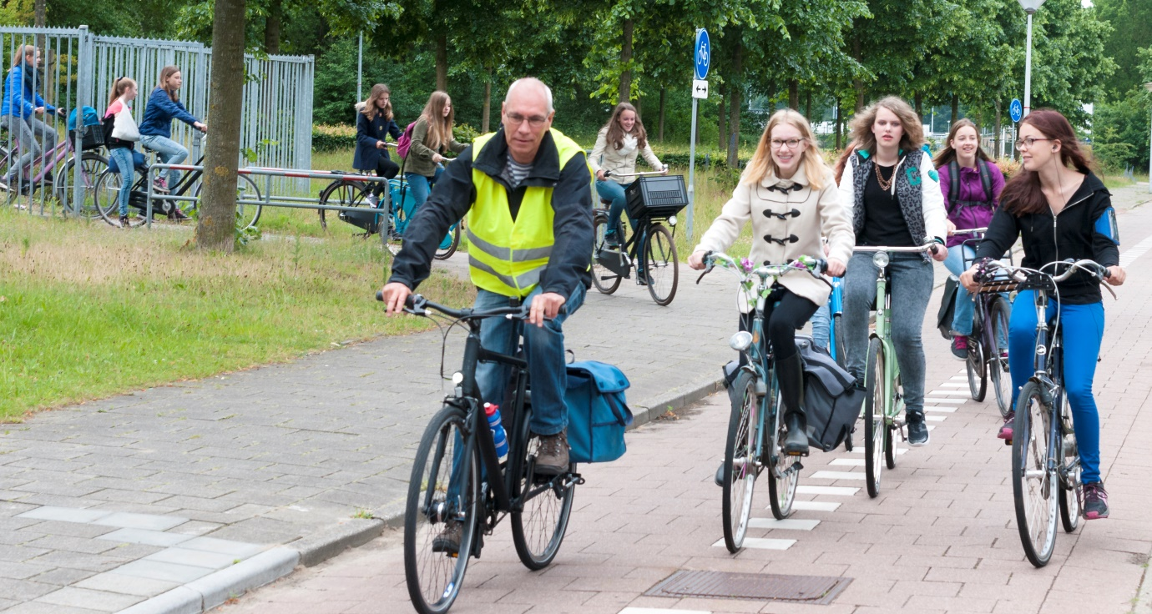
Biking lane at our school with students and one of our teachers.

https://www.youtube.com/watch?v=Wos9Ou6dTDk Why we ride bicycles
https://www.youtube.com/user/markenlei Biking in the Netherlands
https://www.youtube.com/watch?v=GyLlw1CgXf8 How to ride a bicycle!
https://www.youtube.com/watch?v=GugsCdLHm-Q Bicycle song

All the best with practicing ;)

