Romania.

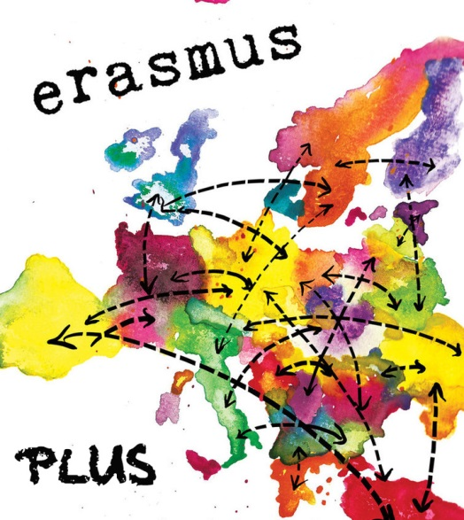
The day we arrived in Romania we go to the school and the we meet the host family. When we meet the host family we go to their house and we were totally tired. The next day we go to the school again and we meet the other countries we showed our presentation to the other countries. We make in groups with different countries a new project. We did research in market research and marketing research. The third day we went to Iasi and a palace before we went Iasi and in Iasi we went to another palace and when we finished it we go to a shopping mall. And then we go back to the host families. The fourth day we go to we went to a shoes factory and a to another shoes factory and when we finished it we went to two monasteries it was very nice. The fifth day we go again to the school we have worked again on the project we learn our information before we had the next day our presentations and when we finished it we go to Betty ice that is an ice factory.

What do I think of it?
I think it was a very nice time and I like to visit new countries and this was a very nice country. The people they are at the project are very nice and I have make a lot of new friends. Everything what we did was very interested. I thought that they lived in 1800 because they don’t have the machines like in the Netherlands they are also late in the technology. But I chose for this country because I thought I go never to this country so it was a very nice country.

Batti Supusepa & Mark Vermin

My week in Romania
I had a wonderful week in Romania. The family was so grateful and Mihaela was so sweet. The palace and the monastery were beautiful, but the long skirts were a little bit hot ;). The slope at the shoe factory was so much fun! The Betty ice factory was cool to see, now I know how ice cream was made and not only how it taste.The shoe factory itself was also special to see. The malls were so big with so much shops, in The Netherlands you have a lot of shopping streets, but not a lot of malls. I also made a lot of friends. The school made also a lot of impression. The square in front of the school was nice and the cantine food was delicious. The houses in Romania are so different compared with the houses in The Netherlands. You have a lot of farmers land and a lot of green, but in The Netherlands you have a lot of industry and the houses are close to each other. The last day we went bowling with the our hosts, it was so much fun. After that sietske and I went to the house from the sister of Mihaela, that was one of the most beautiful houses I’ve ever seen.It was a very new experience to go to a land like Romania. I absolutely go back!
Roos Freriks
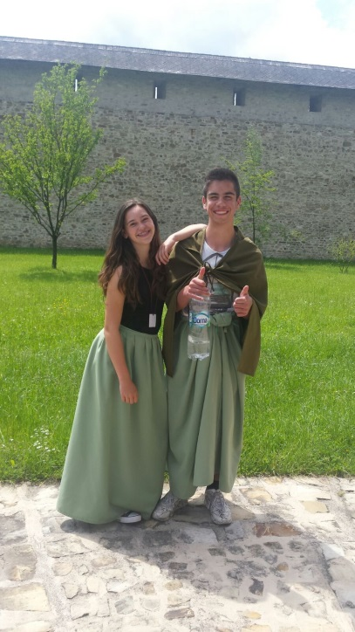
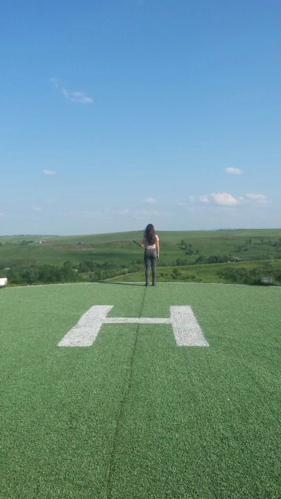
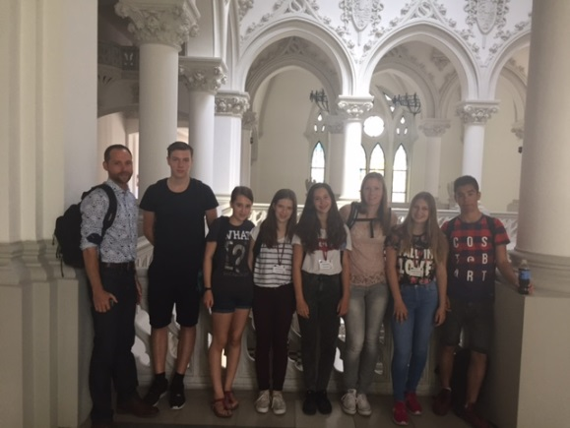

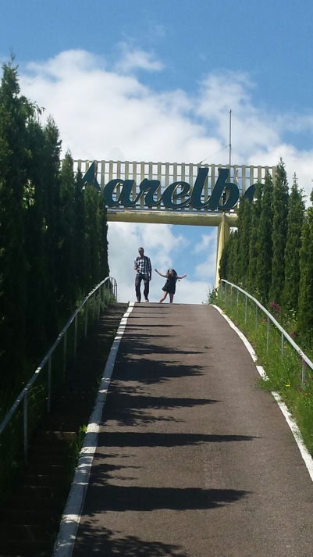

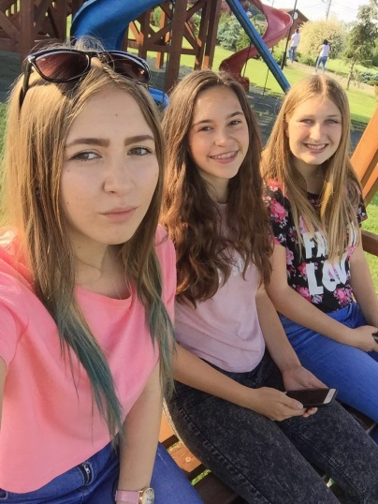

I was in Romenia.
I was in Romenia. I had a very great time there. The family was very nice. Suceava was a very nice and beautiful city. The school was in Suceava and the school was very big. The palace and the monastery were beautiful, but we had to wear big long skirts and there were are so warm. We also went to a shoe factory and that was very interesting and it smells of leather. We also went to Betty Ice it was cool to nice how to make there ice. it's cool to see how big the malls in Romania compared to the Netherlands. The girl where we slept had an older sister who had a very big house. The house was in the middle of no were it was very beautiful and big. In Romania I became really attached to the people there. Michaela was a really nice cute child.
Sietske Hugenholtz

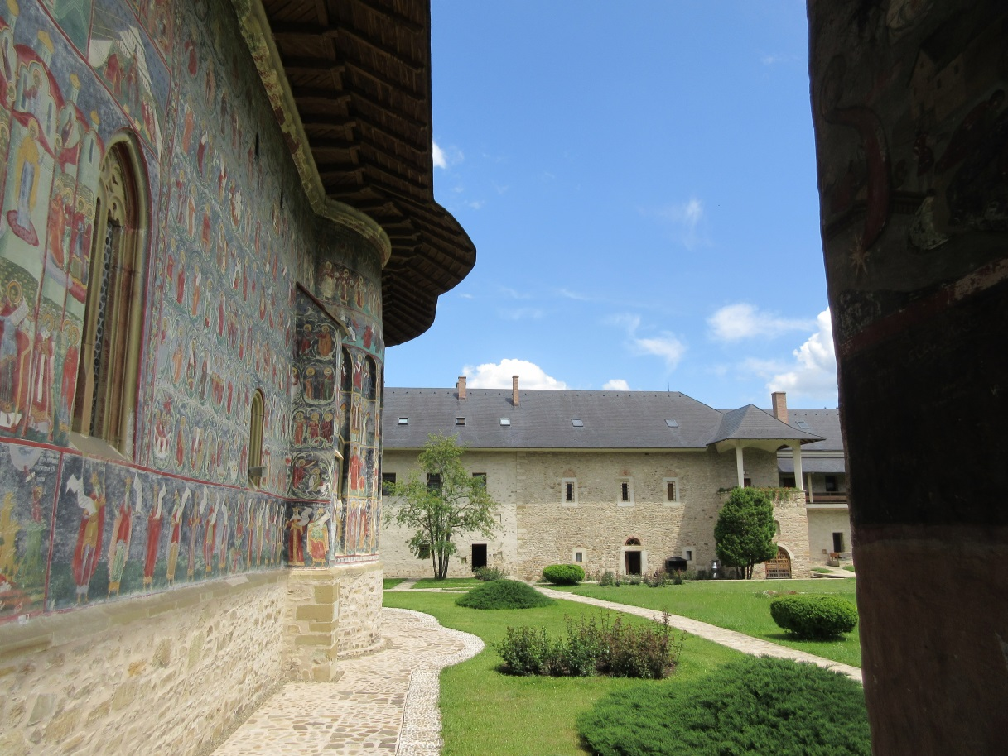

Romenia was Great!
It’s was really great to be in Romania. There are many differences between the Netherlands and Romania. The street was very different from ours. In the city you only see flat, flat and more flats. Between the flats hanging electric wire. Much people don’t have a car. They transport them self by bus, taxi or they walk. And most people don’t have a bike. Also the houses are very different. In the Netherlands most people live in detached houses. Their house was more little than our house. But it was very cozy. They make it feel like home. Our host was very friendly and felt like our friend. It’s was funny that she wants that we met all her friends. The food was very different but interesting to taste al the new tastes. Every day we have walked to school. The school was bigger than our school. It had 4 floors. And there was a boarding school at the school. On the way back to home with the airplane we had a transfer. We had a little bit panic but it were oke. When I think about it later we can laugh about it. At the end I think the whole journey was very beautiful, fun and cosy!
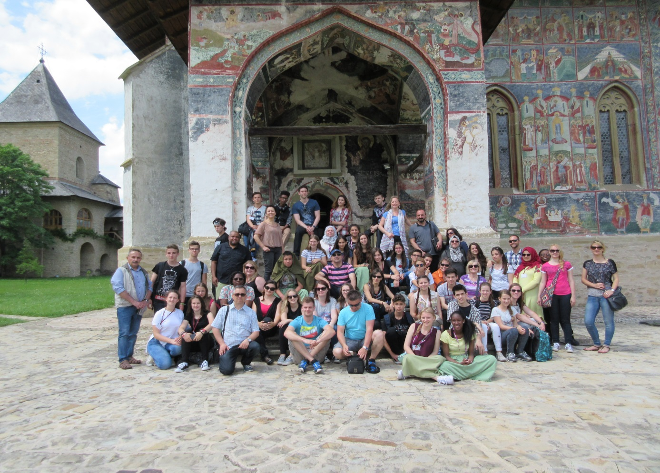
Celine van der Burgh

Romenia and Suceava #beautiful!
We went to the wonderful Suceava in Romania and it was so different, but so beautiful. It was so different because in the city there are only flats and so many people move with the bus or just walk. It’s rare to see someone with a bike. The most adults don’t speak English because in that time they didn’t learn it at school. And they have another kind of money. At dinner they eat a lot of meat and almost no vegetables. We went to a lot of palaces and monasteries and things like that and I thinks that’s a little bit boring. One palace or monastery is enough I think. Because Romania is so big, we had to drive a lot with the bus every day. So some days we were the half of the day in the bus. We went to different factories and we had a lot of workshops about market research. So the third one became boring… On the flight to Romania and the way back we had to transfer in Vienna. And it was the first time with plane for me so that was special for me. But on the way back it was raining and storming so much, so the last flight was canceled and we had an extra day in Vienna. First I really didn’t like it because I was very tired. But we had a great day there. The girl where I and my friend stood was very nice and friendly for us. We had a lot of fun with her. Her mother didn’t speak English so that was difficult. And they made me feel like home. But we have had a really, really great week with much fun and we have seen a lot of the culture.

Iris te Koppele
