Reports Dutch Team

Stijn Berens: 15
Oege Elzinga – 16
Robin Chardon – 14
Rim van Veldhuisen – 15
Xander Janssen – 13
Yamilla Yarja – 15
Niels Vollebregt – 16

Exchange paris:
We went with a group to Paris. The week started with the train. We got on the train to Amsterdam on Sunday. At the Amsterdam station we got on to the Talies who went directly to Paris. When we arrived we got on to the bus who brought us to our hostel. We were greeted at the hostel by the French teacher who would guide us for the coming week. After we left our stuff in our room we went in Paris to look around a bit. First we went to the Champs-Elysees where the arc de triomphe is also located. We weren’t there for very long because we went to eat. We ate at a restaurant called the Monte Carlo. If I’m honest with you was the food nasty. The chicken was to tough to eat, I could break the meat. After our diner we went to our rooms and spend the rest of the night there. We where quickly friends with the English people because we stayed in the same room together.

Monday was our second day of our visit. This day was very boring. We spend the whole day inside a classroom while we listened to different stories and different subjects. The first subject was about the EU and how we are apart of it. After this lecture we got lunch. We had high expectations of our food because we didn’t think the food could be any nastier than the Monte Carlo. We were wrong. This food was canteen food and a lot nastier than Monte Carlo. After our terrible lunch we went back to the class room for the second lecture. This lecture was a lot more fun than the first one because we were sorted into different groups so we could apply the four p’s to a assigned product. There was one of every nationality in each group. Our product was a taxi service. After we worked on our assignment we went to have dinner. Our diner was just as terrible as the lunch. When we were back in our hostel we talked a little with the English guys and went to sleep.

We started our Tuesday with a visit to Facebook; they gave a lecture about there company and what they were working on. I’m not a lot to tell you what they were working on because that’s a secret. They had an amazing few of Paris at Facebook. We went back to the school for our lunch. Our lunch this time was luckily amazing. Instead of the usual canteen food we got food from the school restaurant which was cooked by the students. We got a whole 3 course meal with amazing meat. It was just like it was made in a restaurant. After the lunch we went to the Sacre-Coeur. It’s a beautiful white church on top of a big mountain with an amazing view of Paris. They were busy inside the church so we needed to be very quiet. After the Sacre-Coeur we got some free time in which we ate some crepe. After the Crepe we went back to the school for our diner. It was nasty. After our diner we saw the Marsian. The Marsian is a film about a guy who is stranded on Mars. It’s a really good movie. After the movie we went back to our hostel to sleep.

Wednesday was our fourth day of Paris. We started our day with a trip to Printemps. Printemps is a huge mall in Paris, they sell a lot of brand products there. The special thing about Printemps is that every brand has a small section of the store. Every section has to obey the same rules so that no brand has an advantage over the other. Our assignment was to make different pictures of ways the brands tried to differentiate from each other. After our assignment we went back to school. After our lunch at school we went on a boat on the seine. We saw a lot of bridges and sights. For instants the Eiffel tower and the Notre Damme. After the boat trip we had our diner at school. Then after dinner we went to our hostel to sleep.

We went to the Eiffel tower on Thursday. After we had stood in a long queue we went up the Eiffel tower. We went by the 600 steps stairs to see the stunning view. I bought some souvenirs at the top. After the Eiffel tower we had some free time and we could do whatever we want. After our free time we went back to school to have out diner. This dinner was made by the student and was amazing. It was a 3 course diner and on restaurant level. After our diner we had a gala. This was a lot of fun because we danced with a lot of different nationalities. After that we went back to our hostel to go to sleep.

On our last day before our departure we went and finished our presentations. We finished our luxury taxi service and presented it to our group. After our presentations we got our certificate and our cook book from the school. After that we git some free time and went to the Notre-Damme. The Notre-Damme was just as beautiful as the Sacre-Coeur. We ate some Crepes there. After the Crepes we went to the Monte Carlo for out last diner. This time was the chicken a little bit better but still not amazing. When we went back to the hostel we packed our stuff and went to sleep.

This day was our departure day. First we went on the metro. Then from the metro on the Thalys. Then from the Thalys to Amsterdam and finally from Amsterdam to Ede.

Niels Vollebregt
By Stijn Berens
Monday: We got up at 7 am to sit down pretty early at breakfast. The breakfast was not special. You had bread, a couple of spreads, cereals, yoghurts and cakes. After breakfast we went half 9 at school we were welcomed, we were given a drink and there was a speech which was held by the director of the school. But it was mentioned that we had to give our presentation on Monday instead of Friday. We ran back to the hostel to put on clean clothes packed up our laptop and ran as fast as we could back. All in all, we were on time and our presentation went very well. They understood our concept and found it also very original! After the presentation we were given a tour in the school. It was a fairly large school for the small amount of students they had. The kitchens were quite large and everything looked pretty fine. But the rooms and most of the courses were a bit dated. After the tour we had lunch. The place where you could get lunch was set up quite well and it was buffet style. The food we got was not eating alone! You could always choose between meat or fish with some potatoes or vegetables. But it was never really tasty. Next we had that afternoon a conference and we begun a workshop. That night we went to eat in the canteen. But we had a deal with Ms Marges, if we ate a little food and pretended we liked it we should go to the McDonalds that evening. And of course we ceased here.
Tuesday: We were back at around 7pm took our breakfast and went to school. When we got there we went to divide us about groups one group went to a barber and the other to Facebook. I went to the Barber. Upon arrival we were given a tour of his case. The barber had chosen a beautiful old style for his case. But he not only had a hairdressing salon, NO he also had a bar / smoking room and a private room for private meetings. After the tour we went to the Champs Elysees. When we came back to school, we had lunch but this time we did not go to the canteen but to the restaurant of the school!!! The food was in one word AWESOME! It was really nice and it looked also superb and well cared for. After lunch we had a conference. But these conferences were always super boring and usually the people who gave the conferences spoke very bad English with a French accent so I really could not understand. Oege had indeed fallen asleep during this conference. That afternoon we were given a tour in the neighborhood where the sacre couer is standing. This was a wonderful neighborhood with many artistic artists. From the square with the sacre couer you had a beautiful view over the city. That night we ate again in the canteen :(. After dinner we went to see The Martian. This way was fortunately a good film.
Wednesday: We stood up at the same time as the other days we ate breakfast and went back to school. I can not really remember much about that day. The only thing I can remember is that we had a conference and had an hour marketing workshop. In the workshop we had to invent a product with other international students. The groups were divided so that you were with a student of all the different countries. With my group we had to bring an original soap on the market. After the workshop we went cruising on the Seine. We’ve passed several attractions such as the Eiffel Tower and Notre Dame. That night we ate as usual in the canteen. But this time we moved to the Spanish girls, we have long been talking with them. and after the dinner in the canteen we also went with them to the McDonald :).
Thursday: In the morning we had a conference. This was as usual again very bland. But after we had the conference we finally went to the Eiffel Tower. When we arrived we had to queue for about an hour and half an hour. We had a card which we had access to go up with the stairs. With the steps you could come up to the 2nd floor. This was about 150 meters high. But from this point you actually had a beautiful view over the city. In my opinion I found the stairs less severe than expected. After our visit to the Eiffel Tower, we had a free afternoon. This afternoon we went to the largest shopping center of Paris where several nice stores were found as the Nike store and of course McDonalds;). this evening we'd had a lovely dinner at the restaurant of the school. In my opinion it was even better than the first time we went to eat there. After our dinner we had a gala evening. Music was played and everyone was partying on the awful bad music that was played there. This was also a late evening .
Friday: we had to present our marketing presentation to the whole group. Our product was soap called Rmus it was a soap with the scent of a particular plant. After our presentations and another conference we had lunch. After our lunch we had a free afternoon. During this afternoon we went to the Notre Dame and the neighborhood where Notre Dame is. We ate delicious crepes. In the evening we went to the same restaurant where we had dinner Sunday night.
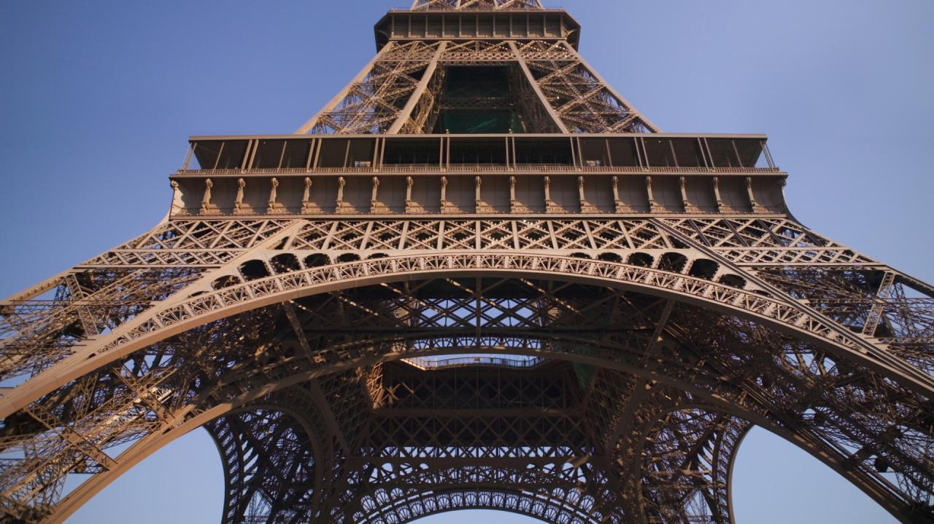
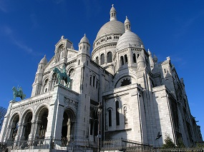
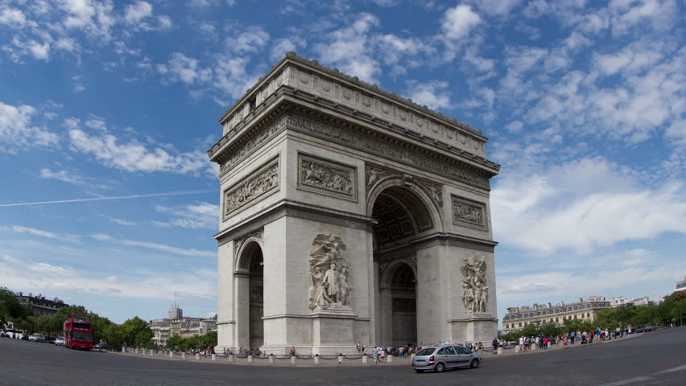
It was all in all a nice week I've learned a lot. Especially about marketing and business

Verslag Parijs 2017
Sunday: We arrived at the hostel after a tiring journey. We received very kindly by Mrs. Elodie. After unpacking the suitcases, we eat at Le Monte Carlo. It was quite chaotic.
Monday: We were very early awake, because the English girls already were showering at 6am. At the school, we were welcomed with a second breakfast and we got a school tour. At 11 o'clock we had quite unexpectedly, the presentation of the app. We only had a laptop, whiteboard markers and an impromptu presentation ...
We got lunch in the canteen and then was the first marketing workshop of one of the English teachers. In the evening eat in the canteen.
Tuesday: Today we were split into groups to visit companies. I went with a group to Facebook. That was very nice. At school we had our lunch in the restaurant of the school, which was super tasty. Much better than in the canteen. After the delicious lunch there was a conference of 2-3 hours of Arti Chef and it was dead boring (except that we got chocolate eggs). From 3 till 5 we went to Montmartre and Sacre-Coeur. At 19:00 am we had dirty food in the canteen and then a very boring movie. In the beginning, a man operated himself. We also had a long wait for the teachers.
Wednesday: Wednesday morning the rest could sleep in, but I went with Mrs. Van Reuler to the upscale department store Hermès. From 11 till 12 we had another conference in the auditorium of a man of the Rodolphe Belin Elegancia hotel group. That was even more boring than the first conference. After lunch in the school cafeteria (fries!) we got the second workshop marketing. We had to work in groups on a presentation about a product. Then we went to hurry to the boat ... and we arrived too late. The road was very nice and there were a lot of Chinese and Japanese. After the trip we got back to dinner in the canteen. It was very salty food.
Thursday: After a short night, a get up early, late breakfast and a long walk we arrived at Gentlemen 1919. Inside we were given a tour of the men's barbershop. It smelled very much like smoke and the back of the case was an illegal bar with lots of whiskey. At school we had the third and final conference of the same man of Gentlemen 1919. Then we got a packed lunch with half a baguette and dirty water prick that I had at least. We went by metro to the Eiffel Tower. We waited one and a half hour in line. And then we were at the Eiffel Tower, but we had
to be down in time for the visit to the Elegancia hotels. But the Slovenes, Turks and Poles refused to come on time, so the visits were canceled and we had three and a half hours of free time, according to the English teacher. But when we told Elodie, she said that was not true or something. She was almost crying.
In the free time we went to the huge shopping center La Défense.
In the evening we had a delicious farewell dinner and a gala until 00:00. That was really nice!
Friday: This morning we woke up late, but fortunately we were still in time to finalize the marketing project. We were in the nick ready to present in the auditorium.
After the last school lunch we had another free time. We went to eat a crêpe at Notre Dame. Then we went walk around and buy souvenirs. Taking the metro was a disaster! All subways were packed. After a long road and a time to be lost, we finally arrived at Le Monte Carlo for the very last dinner in Paris. Then we went back to the hostel.
It was a marvelous week. I’m glad I joined in.
Robin Chardon

Exchange paris 2017
I was really lucky, I was not planning to go to Paris as an exchange but there was a boy who planed to make this exchange but he got ill. So I could replace of him! I was so happy.
On Saturday night I went to packed my cases because Sunday was the day!
On Sunday, I woke up early (because we went at 9:41 )
When we arrived my family was saying goodbye to me at the station. My sister was crying because she thought it was exciting for me. We went through ede Wageningen to central Amsterdam by train. After waiting 40 minutes we went with the Thalys to Paris. It took about 3 hours until we arrived in Paris. (15:00) when we went by a chock-full bus to the hostel. The hostel was very nicely decorated. Robin and I were in a room with four English girls. We went to explore paris. Then in the evening we went to the restaurant Le Monte Carlo. The food was normal . Afterwards we went with another group to the Champs Elysee. I also made a few pictures. Very impressive.
Then I went to sleep because I was very tired. The next day I woke up early because the alarm had their girls from England already put a quarter past five. I had breakfast as fast at the hostel .To 10 for half nine we went to the cooking school. We had to wait in a very nice large hal.We had to sit in a kind of cinema seats and received an explanation of what we are going this week do.We had to do our presentation that was very nice. Many people were excited about it and we got tips. After lunch we had a presentation on marketing, we were divided into groups and each group one person in the country. We had to make a long residual product. I got as a product: a lunchbox. Together with students from the group, we have a whole plan, we also know each other (icebreaker) We visited an office of facebook here we were getting paid a presentation on how facebook. Then we got a lunch to the students of the cooking school as a surprise. It was really delicious dessert I liked the best. In the evening we watched a movie the Martian, it was very nice with all kinds of students. On Wednesday at 9 00 Rim, Stijn, Ms. Margins and I went to a hotel called Makassar. We got a tour there. When we had time so we went to the Champs-eleysees, where I bought a sweater. Then we got a conference on hotels. Then had another moment leisure and went to dinner with our Dutch group at lunch. It was reasonable. Then we went to the boat where I made friends again. We got food in the evening which I found not so good so we went with the Spanish to the Mac Donalds. The next day I traveled with Robin and Mrs. Marges the gentlemen.it look very special. There was behind the barbershop a drinking area and a smoking room. It was very interresting.Afterwards we had a conference of the barber who worked there. He also told about the 4p's where we learned about the project marketing (price, place, promotion and product)
After the conference we went to the Eiffel Tower !!! There was I waiting for the whole week. It was so nice. We went to the second floor and it was really cool. You had a very nice view. We had forty-three are back down. We were right on time as always but a few others were not on time. At first we missed the hotel to visit but we had 7 hours free time! We went to a very big shopping center. To 7 pm we went to eat again .. now at the restaurant of the school. The food was very tasty after dinner we went dancing in another room. It was very nice with everybody and everybody was black / white dressed. Around 12 o'clock it was over and we had pretty much danced.I was really tired so wanted to go to sleep quickly. Unfortunately, this is not because there were bed bugesin our room. I was covered in red bumps. De last day of the exchanges; in the morning was the last time we worked on the project. Our group worked well together. The presentation went well. After the presentations we had oo school lunch again. I had visticks visticks and still visticks. I found it really nice. After lunch we had again so went leisure to a place in Paris where many students live there were all shops that were not too expensive. We got there from mrs Reuler and mrs Marges a pancake and a drink. In the evening we had a farewell dinner at the restaurant la monte carlo. After dinner and farewell the spanish people (because they were not in the hostel) We went there to sit in the lounge with almost all countries it was very cosy and two Turkish Could speak Dutch so it was very nice of them. We then also made a groepsapp with everyone and added another on social media.
Through this exchange, I learned a lot: the different cultures out there, the nice people and project marketing.
It was really fun to make this all along. It was a nice week
- Yamilla Yarja 3ha1
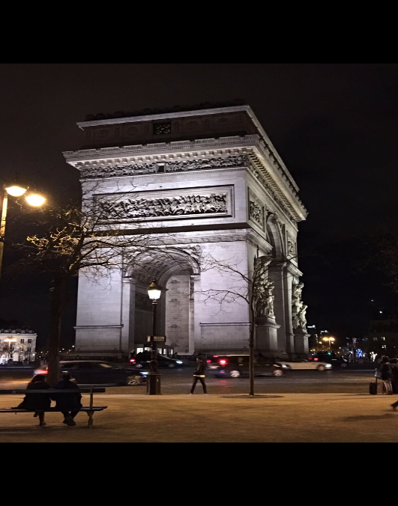
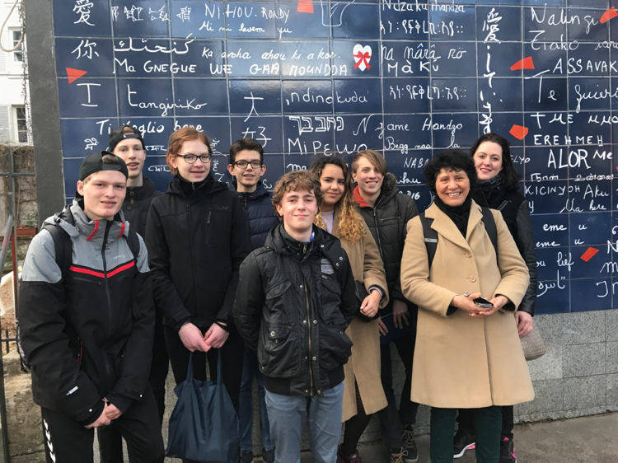
- Pallas athene college Ede,the Netherlands

Paris exchangeproject.

We went to Paris with the Thalys.
When we got in Paris we went with the bus to the hostel. In the hostel we got to see our room, which wasn’t to bad. It was a lot of fun with the other guys in our room.
Day 1
On Monday we had the opening presentation and breakfast at the restaurant/school. The breakfast was delicious.
After the opening presentation we got a tour of the school. the school in my opinion looked a little bit old. The school was rather big and the kitchens looked nice.
After that we had our presentations. In my opinion I thought all the presentations were amazing. Everyone had put a lot of energy and work into they’re project/presentation. Problem was sometimes that some people weren’t the greatest at pronouncing/speaking English so it was hard to understand what they were saying. But in the coming days it became a lot easier to understand everyone.
After the presentations we went to get lunch in the cafeteria. Personally I didn’t like the food it tasted a lot like unions.
After lunch we got the presentation about marketing which was rather interesting it taught us at least a bit about marketing. We also got assigned teams in which we would work to make the best marketing campaign for our little project.
The we got dinner in the cafeteria again. The we went back to the hostel were went to sleep.
Day 2
The next morning we got breakfast at the hostel and we went to school and from there my group went to Facebook. There they told us about what Facebook did and how they did it. It was quite fun.
Then we went back to the school to get lunch in the cafeteria.
The we had a conference in the schools auditorium which in my opinion was rather boring. After that we got dinner in the schools cafeteria. After dinner we went to the auditorium again to watch the movie the Martian which in found quite entertaining.
The we went to the hostel again and went to bed.

Day 3
When we woke up again we went to get breakfast in the hostel. Then we went to the school and from the school we went to a big company in which were a lot of different brands from which we had to say how they tried to stand out from the others. After that we went to the school to get lunch.
After lunch we went to go further with our marketing project. We were set in our groups we had to start with deciding whom would do what. After that we got to work on how to market our product. We put a lot of work in our marketing. After that we got a cruise on the Seine. From our cruise we could see the Eifel tower and a few other beautiful buildings. After that we went back to the school to get dinner. After dinner we went back to bed.

Day 4
When we woke up we ate our breakfast at the hostel and went to the school to listen to a conference from Maxime Simoneau the Gentlemen 1919 founder. He told us about Gentlemen 1919.
After the conference we went to the Eifel tower there we had to stand in line which was boring. But it was a lot of fun on the Eifel tower. There was only a slight problem when we got down from the Eifel tower it turned out that some of the groups were still upstairs so we couldn’t go to the luxury hotels. So we had some extra free time to shop our go for lunch because this time we had to get lunch for ourselves.

In the evening we had food in the restaurant which was amazing. After dinner we had a Gala which was a lot of fun. After the Gala we went back to the hostel and went to bed.

Day 5
When we woke up we went to get breakfast. After breakfast we made the finishing touches to our marketing project. After that we presented it. In my eyes everyone did a amazing job to make so much in such little time. After that everyone got certificates.
In the whole afternoon we had free time. After that we had our Farwell dinner in le monte Carlo the food was decent.
The we went back to the hostel for our last night there.

On Saturday we went back to our home in Holland

Oege Elzinga Holland student

