2018
Students of Pallas Athene College
1-1-2018
Business plan BottledWonder

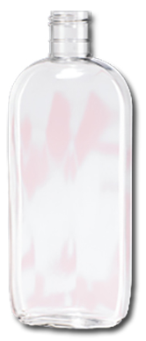
What is Argan Oil exactly?

For our product “Bottled Wonder” we use Argan Oil, also called Moroccan gold. Argan oil is so popular because it is good for skin, hair and even nails. It takes a lot of work to get a little oil out of a pit, that’s why the oil is very expensive.
Argan oil is rather pricy: up to 160 euros per liter. The oil is extracted from the kernel of a fruit that grows on the Argan tree.
To sell this product, Bottled Wonder plans to present the oil in a very nice packaging by putting the oil in bottles of 100 ml and 50 ml. A label that shows luxury is applied to the bottle.

<= Our 100ml bottle of Argan oil.
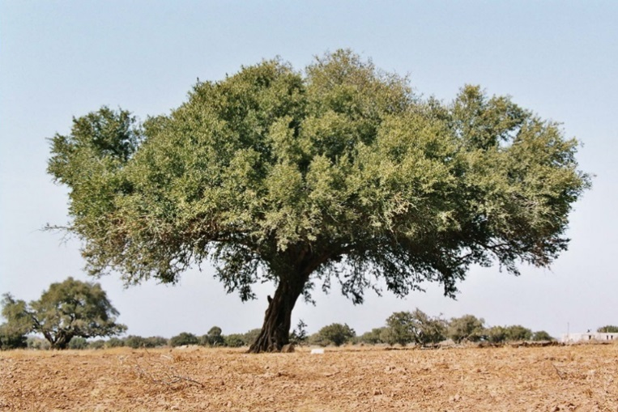

SWOT analysis of Bottled Wonder

Strength  - fine quality of Argan oil  - sells below the market price  - buys cheaply (purchase price) | Weaknesses  - lots of competition  - no known brand  - not for sale in retail stores
Opportunities  - the product is very cheap compared to other brands; so it can be very good. | Threats  - People will not quickly step away from real brands people are attached to.

Bottled Wonder only reimburses the product if it is not properly filled and/or damaged.
Bottled Wonder charges €9,95 for a 100 ml bottle Argan oil and €5,95 for a 50 ml bottle.

Shares

In order to implement Bottled Wonder’s plans, Bottled Wonder needs to sell 80 shares worth 400 euros. Bottled Wonder expects to make a 512 euro profit. Bottled Wonders gives 40% to their shareholders. This equals 205 euro (€512/100X40 = €205)
This (205 euro) is divided by the number of shareholders (80) which equals approximately 2,50 euro per share extra.

Results market research:

All results are based on 75 surveys.

Percentage of boys and girls who filled in the survey

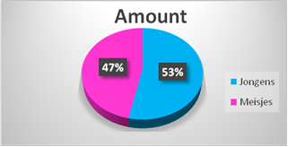

Wanted quantity 50mL or 100mL

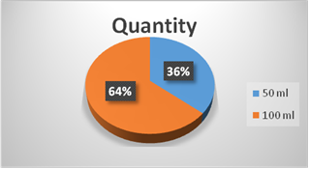

Respondent’s interest

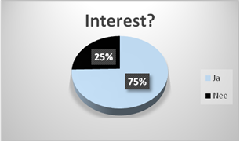

How much are people willing to spend on the product of 100mL?

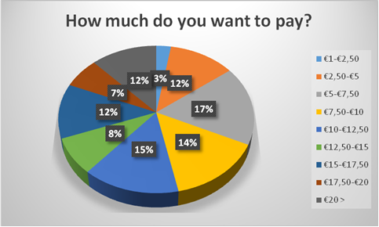

All exact prices were added and then divided, out of this came an average of €11. But because we don’t want to ask high prices straight away, Bottled Wonder asks €9,95 for 100ml and €5,95 for 50ml.

To familiarize people with Bottled Wonder we use a website, Facebook page and an Instagram page. And we also take care of customers to get a good reputation.

Bottled Wonder expects to sell lots of little flasks of Argan Oil, mostly because we can sell it below the market price and because it is real Argan Oil from Morocco. But also because Bottled Wonder wants to sell the oil in flasks of 50ml and flasks of 100ml, creating an opportunity for customers to choose from more sizes.

Below you will find the financial information of Bottled Wonder.
Bottled Wonder is buying Argan oil for €20 per litre from Morocco. They will put the oil in bottles of 50ml and 100ml with a new bought funnel. The funnel costs approximately €4. The 50ml and 100ml bottles will cost about €1 per bottle. The bottles will have a nice and handy cap (disk cap).

Transport | €20 | €20
7 litre Argan oil | 7 x €20 | €140
3 litre Argan oil | €0 | €0
70 100ml bottles | 70 x €1 | €70
60 50ml bottles | 60 x €1 | €60
Funnel | 1 x €4 | €4
130 labels | 1 x €40 | €40
Young entrepreneur/ undertake | 1 x €25 | €25
Total |  | €359

Sell 60 50ml bottles for €5,95 (incl 21% VAT) per unit.  Sell 70 100ml bottles for €9,95 (incl 21% VAT) per unit. | 60 x € 5,95 = € 357 revenue  € 357/121 x 100 = € 295  70 x € 9,95 = € 696,50 revenue  € 696,50/121 x 100 = € 575,62
€ 575,62 + € 295 = € 870,63
€ 870,63 - € 359 (costs) = € 511,63

In short we make €511,63 profit per 70 100ml bottles and 60 50ml bottles.
To calculate the break-even point, we must take into account that we sell 2 different products with two different prices.
In total we must sell 130 bottles: 70 100ml bottles and 60 50ml bottles.
We will calculate the percentage of this | 70/130 x 100 = 54% and 60/130 x 100 = 46%
Then we will do the percentages times the amounts | €8,22 x 54% = €4,43  €4,92 x 46% = €2,26
Then we add this: €4,43 + €2,26 = €6,69
€359/€6,69 = 54 St.
We will put this in the right proportions | 54 x 0,54 = 30 units of 100ml bottles  54 x 0,46 = 24 units of 50 ml bottles

To start our company we need about €400 for any setbacks. Every share costs €5, so 400/5 = 80 means that we have to sell at least 80 shares to start shipping and eventually start selling the Argan oil. Bottled Wonder sells the Argan oil at school, but also to spa’s, hammams and hairdressers.

