St. Hubertus Hunting Lodge

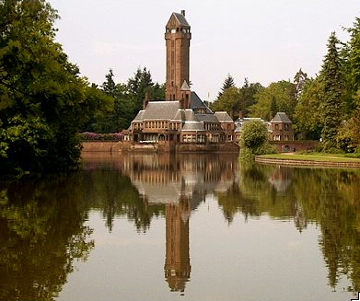
The St. Hubertus Hunting Lodge is one of the most outstanding buildings designed by architect H.P. Berlage. In 1914, the very wealthy couple Anton and Helene Kröller-Müller asked Berlage to design a summer residence with all the latest modern conveniences.
The hunting lodge was a ‘Gesamtkunstwerk’ (collective masterpiece) which incorporated designs made exclusively for this country house: the park, the building, the interior, the furniture and even the dinner service with cutlery, chinaware etc.
The largest privately-owned country estate in the Netherlands
Anton Kröller and Helene Müller came from wealthy families of traders and industrialists. Over the course of many years, the couple bought significant tracts of land in the Veluwe region which they joined together to form the De Hoge Veluwe National Park; by far the largest, privately-owned country estate in the whole of the Netherlands. The couple commissioned the famous architect H.P. Berlage to build them a hunting lodge in the middle of the estate. Berlage was given complete freedom for his designs, and inspired by the story of the patron saint of hunters, Saint Hubertus (see page 5). He designed a hunting lodge with two wings in the shape of a deer´s antlers, and a tower in the middle representing the cross.
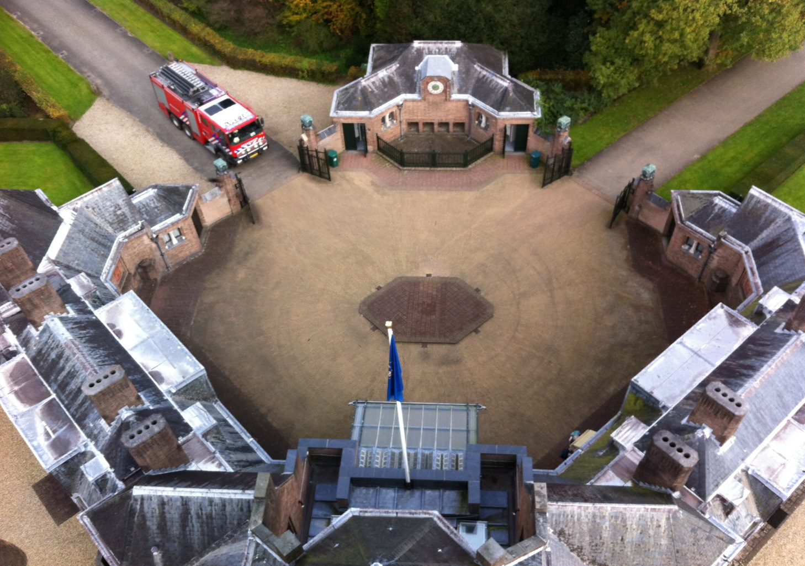
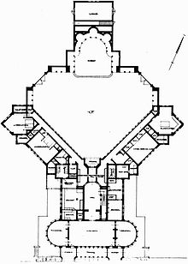

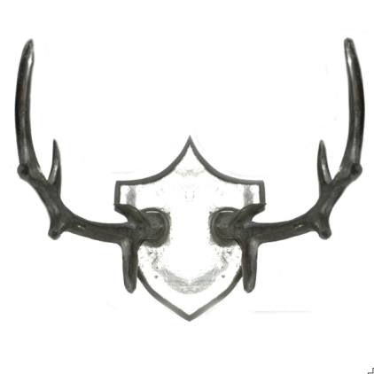

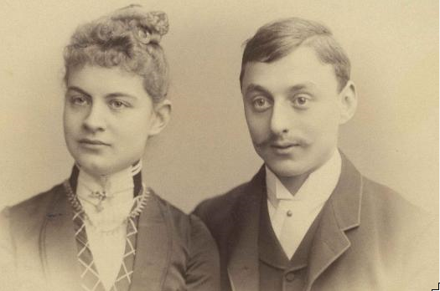
Kröller-Müller
While Anton was out hunting for game or for business, Helene dedicated herself to contemporary art and modern architecture. She acquired an extraordinary art collection and became heavily involved with the design of the hunting lodge. No expense was spared in building the lodge and the house had its own generator for electricity, hot and cold running water, its own spring, central heating, a central vacuum cleaning system, and an elevator (which still functions perfectly). The windows on the ground floor can be sunk (into the cellar walls) like car- or train windows…. All the very latest gadgets of the early 20th century.
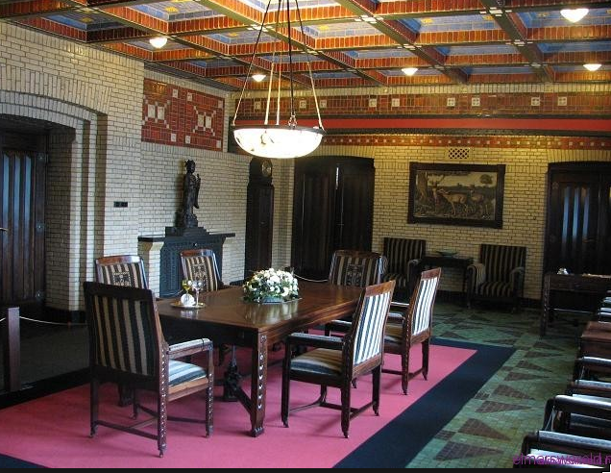
Hunting lodge with and unusual interior
The most eye-catching aspect is the 30-metre-high watchtower that overlooks the entire estate. The building’s unusually clean lines and the use of 'honest' materials is also a special feature.
In the interior, the use of different colored, specially-glazed bricks creates different atmospheres throughout. Every detail was designed exclusively for the hunting lodge, right down to the door handles and the tea service. After the Kröller-Müllers died, the national park and the St. Hubertus Hunting Lodge were opened to the public.
From September 2012 until June 2013 the Hunting Lodge has been restored thoroughly. Old craftsmanship and new techniques were combined to give the Hubertus Hunting Lodge new glory for the next 50 years…
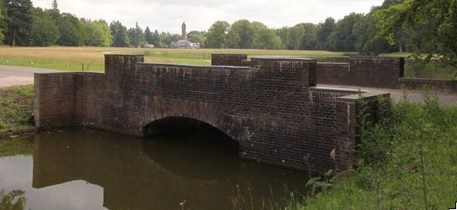
“Gesammtkunst” Berlage designed everything for the Hunting Lodge; the building, the surroundings (he designed large parts of the park that surrounds the lodge, the huge pond, the bridge and the pump house). Also the complete interior and even the smallest details like coffee cups and teapots, spoons, forks and dishes came from his plotting board.
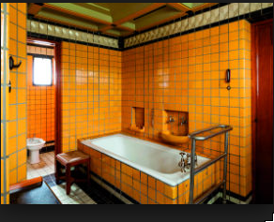
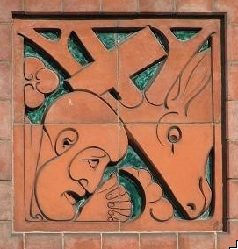
photo 1
photo 2
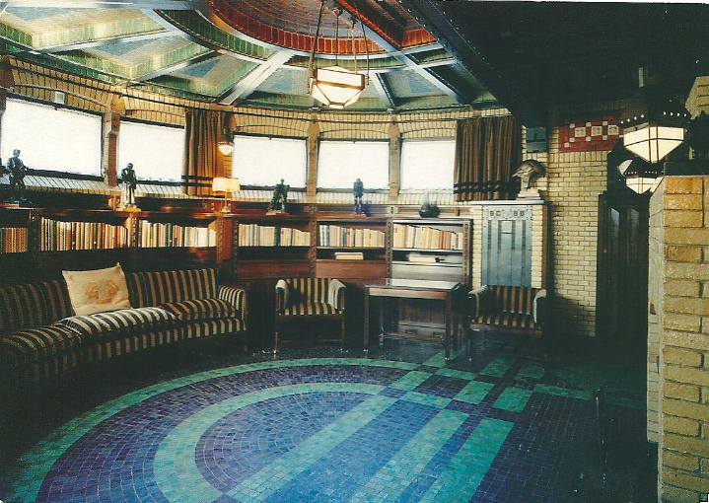
photo 3
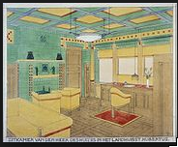
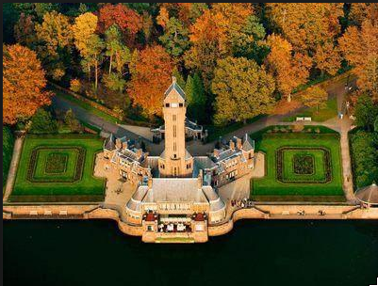
photo 4
photo 5
photo 6
The relation of St. Hubertus and the Hunting Lodge….

St. Hubertus is the (patron)saint of the hunters.
There are two legends for the origin of St. Hubertus
1: Hubertus was an earl (count) in the late 7th and early 8th century. He lived a life of luxury and wealth amongst the feudal aristocrats. One day, “Good Friday” (instead of praying in church) he went out in to the forest for hunting. Suddenly he meets a deer with a shining crucifix in his antlers and there is a voice that commands Hubertus to stop his decadent way of life and commit himself to Jesus and the Church. So he does. When Hubertus dies (722 ?) he is a mighty Bishop (of Maastricht and Liège). This legend however was written hundreds of years later on.
2: In the Roman empire (Trajanus +/- 100 )there is a certain “Placidus” (a heathen, Roman officer who is hunting for deer. After a long exhausting hunt, he meets the deer and as he wants to shoot it……. He sees a shining crucifix between its antlers… He too hears a voice, gets baptized and becomes a very brave, good Christian; his new name was: Eustatius. There is a lot more to tell about this Eustatius, but….
Probably in the 14th century the two legends were joined to one “new and true” story of Saint Hubertus. Now monks and artists could write and paint about St. Hubertus and his miraculous life… St. Hubertus became the patron of the hunters.

So now you might ask: “Did Berlage designed the summer house to the shape of a deer’s antler, like the one that St. Hubertus saw in his vision ?”
Explanation 1: Berlage took the picture of the St. Hubertus Antler as a basis for designing the Summer House.
There is of course some resemblances but some contemporary architects and artists made a study of Berlage, the Köller-Müllers, their summer house and the Park and they came to a different conclusion:
Explanation 2: Berlage wanted a building, that “embraces” its inhabitants and visitors. That explains the half round shape of the buildings’ side wings. And the “shining crucifix”? Well, Berlage was very fond of towers; a tower connects the building in its’ surroundings with the skye…. So that ‘s why…..
Your assignment: Name: …………….. ………………………………..

- Read the information of page 1 – 5. Mark all the words you don’t understand. Try to get an explanation for these words so that you do understand the information about The Hunting Lodge.
- Than take a good look at the “Jachtslot St. Hubertus” Try to locate some details that are photographed on these pages.
- Discuss in your group which of the two explanations ( The “St. Hubertus legend” or the “Embrace the visitors theory” is inspired Berlage to design the Summer House “St. Hubertus” Try to come to one conclusion for the whole group.
- Than fill in A, B, C and D
A) I ( we ) located / visited the following details (photo’s): …… ….. …. ….
…… …….
B) We talked in our group about the two explanations of the “Antler design” and
my group concluded that explanation ……. ( fill in 1, or 2 ) is most likely
the best.

C) My personal opinion about the two explanations is, that explanation ………….
( fill in 1, or 2 ) is most likely the best. I came to this conclusion because

……………………………...............................................................................................

……………………………...............................................................................................

……………………………...............................................................................................
D) the use of 'honest' materials is also a special feature (page 2) What “honest
materials did you see ?

………………………………………………………………………………………………….
…………………………………………………………………………………………………
.………………………………………………………………………………………………….
Museonder

Time:
20-25 Minutes
supplies:
Pencil, booklet

Have you ever really looked into the soil? It’s possible in the Museonder, the first underground museum of the world, situated in park de Hoge Veluwe
.

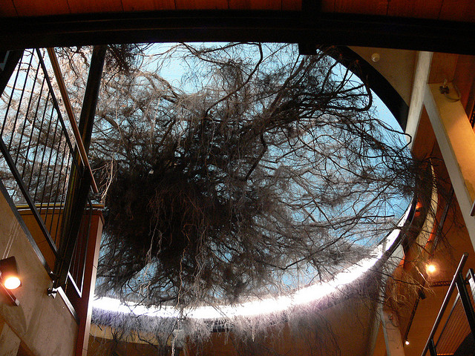

This Museum gives a surprisingly image of what lives and used to live under the surface. The exhibition takes you deeper and deeper into the earth

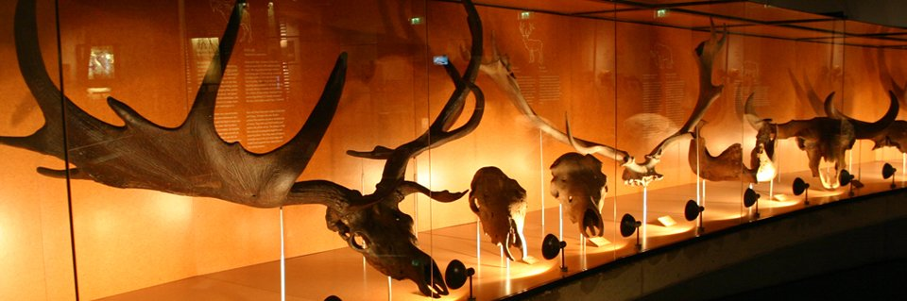

Tasks

The tasks correspondent with the three departments in which the exhibition is divided.

- Long live the soil
- The deeper earth buried history
- Water and fire

Tasks will be made at each different department of the museum.

- General Task Let your group take as many pictures as possible from fossil teeth of herbivores during your visit.

- Long live the soil

These tasks start at the end of the long corridor, the one with the nice wooden banister. It ends just before the footbridge.

The beech
Listen to the roots!

- Are the roots of the beech going deep into the ground or do they take root at the surface?

…………………………………………………………………………………………………..

- How many liters of water does an adult beech consume on a summers day?

…………………………………………………………………………………………………..

- How many meters is the diameter of the roods together.

…………………………………………………………………………………………………..

- Which part of the root of the tree absorbs water. Make a drawing about it.

- Describe in 1 word how you feel when you stand underneath the roots.

…………………………………………………………………………………………………..

Life out of death material
The video shows how death material is been broken off

- Which organism plays an important part during this process?

…………………………………………………………………………………………………..

- The deeper earth buried history

This part starts just before the footbridge and ends beneath the big stairs.

Drama in mediaeval time
Before the footbridge on your right side you see three bottom profiles. It shows you a lot of history. During mediaeval time a lot of farmland from Kootwijkerzand was filled with drift-sand. Farmers tried to plough it under it to get rid of it, you can see this in the bottom profile.

- Draw this part of the profile here.

In the middle and the right profile you can see the field has got a darker colour than the drift-sand.

- Explain why.

…………………………………………………………………………………………………..

…………………………………………………………………………………………………..

The wind builder

- Explain the special form of these stones.

…………………………………………………………………………………………………..

…………………………………………………………………………………………………..

Land ice
Watch the video, pushed from Stockholm to the Museonder.

- Which influence did the land ice have on the development of the existing bottoms

…………………………………………………………………………………………………..

…………………………………………………………………………………………………..

- How did they take the stones with them on this journey?

…………………………………………………………………………………………………..

Speaking stones
On this wall you see different kinds of stones and soils. Put your hand on them. Don’t be scared when they start talking to you!

- Fill in this table. How did these stones come to the Netherlands

Rivers | Wind | Land ice

- Water and fire

Groundwater in the Netherlands
Look at the groundwater map on the back wall

- Where do you find the biggest supply of groundwater?

…………………………………………………………………………………………………..

- How does the pollution spread?

…………………………………………………………………………………………………..

Drought in the Netherland
Watch the video at the wall.

- Describe shortly why there is drought in the Netherlands.

…………………………………………………………………………………………………..

…………………………………………………………………………………………………..

Walk upstairs towards the exit
When you come outside there are a line of big stones.

- Find out which one is the oldest make a note of the age and the name of the stone. Than make a picture of the stone tighter with your group.

…………………………………………………………………………………………………..

